Worksheet 1: Investigation
Task 1
- Hand measurements are used in ergonomics and anthropometrics to enable product designers to create objects and clothing that fit the greatest proportion of people.
- A person’s hand size is measured by the length of their hand. Using a tape measure or ruler, measure your hand length in millimetres.
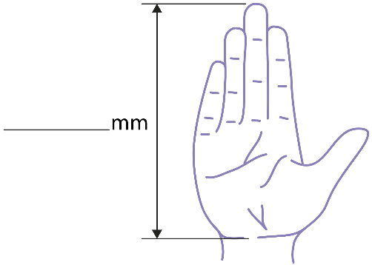
- An anthropometric study of 100 adult males and 100 adult females found that hand sizes for adult males ranged from 173mm to 219mm, with an average of 193mm.
The average hand size for an adult female is 180mm.
(The largest hands in the USA belong to an American football player, DeForest Buckner, measuring 298mm – that’s longer than a sheet of A4 paper).
How does your hand size compare to the average adult male or female?
- In the same study, it was found that the 5 smallest female hands measured 165mm or less. This means that if a female has hands that are 165mm, 5% of other females have hands that measure the same or less. They are said to be in the 5th percentile.
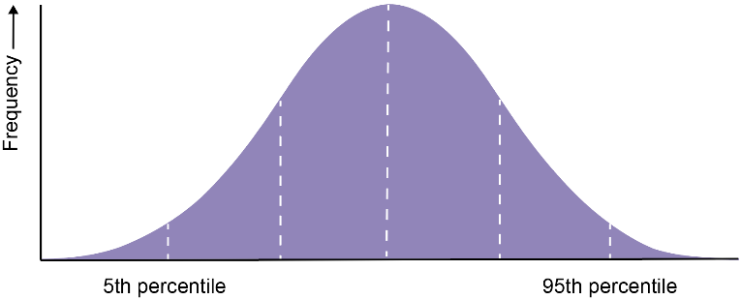

What does it mean to say that someone is in the 50th percentile?

- The hand measurement of adult males at the 95th percentile was found to be 211mm.
What does it mean to say that someone is in the 95th percentile?

- How might statistical data on hand sizes be useful to a product designer of an air curtain style hand dryer?
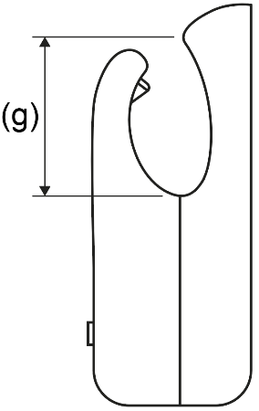

- Given the information in part (d), suggest a suitable depth for the dimension (g) shown in the plan above. Justify your answer.

Task 2
- Using the seating options shown below as inspiration, write a detailed design brief considering the clients’ needs. Think about the environment they will be placed in and the suitability of materials.
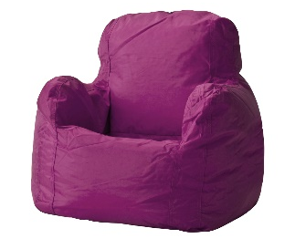
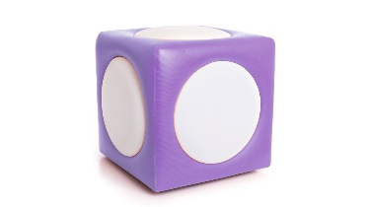
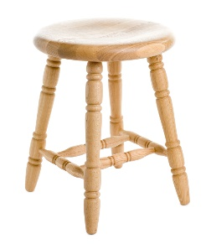
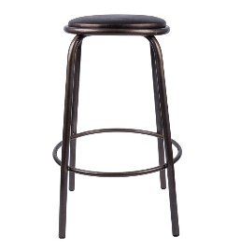

- Suggest how environmental, social and economic challenges may influence the choice of seating.

