Presenting Information – Impact Statements

Some of the factors we need to consider when presenting information.
We have looked at the target audience. We need to consider:
Gender
Age – the method must be appropriate for the age group the information is targeted at
Ethnicity - need to consider people for whom English is not their first language. Cultural sensitivities also need to be considered so as not to cause offence
Income – advertising products to groups who cannot afford them is not a good use of resources. This will also impact on the choice of presentation method. Communicating benefit information via the internet to people on a very limited budget means that those who cannot afford internet access are excluded from the information that they most need.
Location – mobile devices mean that we can access information anywhere whether via Wifi hotspot, 3G,4G,5G. However, some parts of the UK have limited mobile access. Data that is likely to be accessed via mobile networks needs to be as small as possible to optimise download times and the impact on data allowances.
Accessibility – Information provided to a small group of experts in the subject will be presented in a different way than if that information is to be shared with the wider public. Accessibility also includes the availability of information to disabled users.
Visually impaired users may use large print versions of documents, screen magnifiers, screen readers, audio description of videos or braille printers.
Hearing impaired users may need subtitles (voice to text and audio description) or signing
Task 1
Research: You work for an organisation which is required to provide international travel information to travellers to and from the UK. Your boss is aware that these travellers include disabled travellers. The information includes, text based, images as well as videos.
Your boss has decided to make the travel information available via the Internet and a mobile phone app.
He has asked you to use the internet research a range of software tools that are available to help present this information to disabled users.
Evidence required
- Name of package
- Screenshot of package logo/packaging
- Brief description of what it does
- Cost
You may choose to display these results in a table

Task 2
Making an Impact
We have all heard the phrase : “ a picture paints a thousand words”
All information has an impact on the people who access and use it. Sometimes the impact of information can be greater by how it is distributed. For example, if the information is to be distributed in a presentation, the impact could be increased by using sound, video and graphics as elements of the presentation.
Numbers can have a greater impact if they are shown in a graph/chart because the audience can visualise the numbers more easily. Diagrams can also increase the impact of any information. This is because, along with graphs/charts, people find it easier to understand diagrams rather than read text.

- Which word stands out the most in the paragraphs about?
- Which is the next most significant word in the text above?
- What effect has been used on the word greater to help convey it’s meaning?

Task 3
Look at the following information:

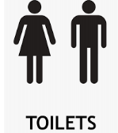
What is the message?

Where could it be displayed?

What methods are used to convey this information? (Text/Image/Video/Graph/Chart/Audio)

What is the target audience?

Why is this method of presenting this information appropriate?

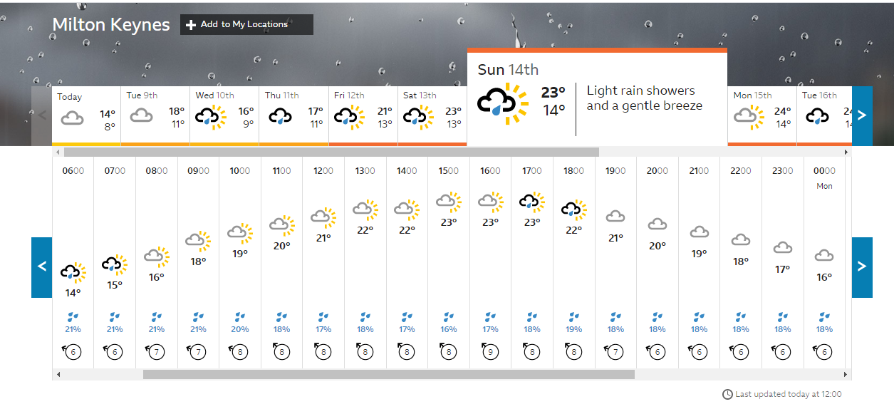
What is the message?

Where could it be displayed?

What methods are used to convey this information? (Text/Image/Video/Graph/Chart/Audio)

What is the target audience?

Why is this method of presenting this information appropriate?

What is the message?

Where could it be displayed?

What methods are used to convey this information? (Text/Image/Video/Graph/Chart/Audio)

What is the target audience?

Why is this method of presenting this information appropriate?

Task 4
In the real world you must …..
- You must produce the task by the deadline
- You need to plan your time to make sure you meet the deadline
- You need to select the correct tools for the job
- You need to locate all the components to be included in your task
- You need to allow time to check your solution is correct
- You need to keep checking you are on schedule
Your boss needs you to produce a stop smoking poster urgently. He requires two posters for two different target audiences. The poster must be appropriate for the target audience, include some relevant images. Include facts about the dangers of smoking. Must give details of where to get help to quit. You can choose which target audience you want to use. He has given you 2 hours to complete the following task.
- Your boss is anxious that you are not going to make the deadline so wants to see a plan of how you are going to use the two hours before you start.
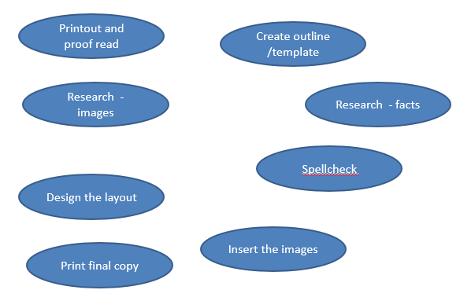
Some of the stages you may need to consider. Add rows to the table if necessary
Complete the following planning grid. Make sure you only allow 2 hours in total.
Sub-task | Timing | Resources | Notes

- Get organised do your research
- What do you need to find?
- Locate the information/images
- Remember you cannot simply copy and paste text from the internet into your own work. YOU MUST WRITE IT UP IN YOUR OWN WORDS

- Create the poster. This can be using software or drawn by hand using images you draw or images cut out from magazines etc. (ask permission first!)
Email your time plan and your poster to your teacher

