Homework 1: Investigation

1. Primary and secondary research are both necessary for the modern designer.
(a) Give one example of primary research. [1]

(b) Give one example of Secondary research. [1]

2. Evaluate the advantages and disadvantages of each of the computer mice below with regards to ergonomics, anthropometrics, manufacturing cost and durability:
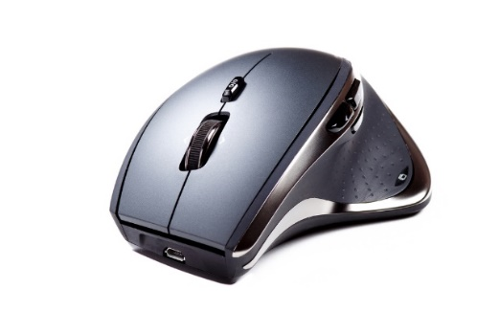
Mouse A Mouse B
Advantages of Mouse A | Advantages of Mouse B
Disadvantages of Mouse A | Disadvantages of Mouse B
[4]

3. A skateboard helmet is shown below.
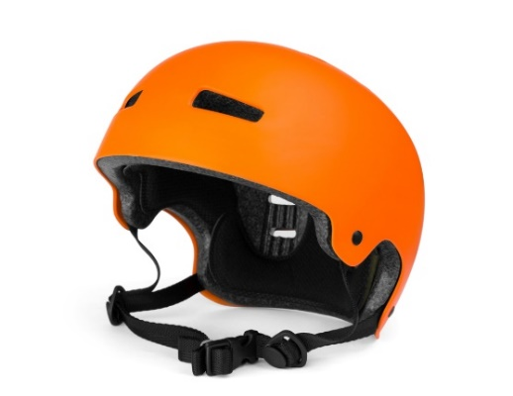

Suggest two ergonomic considerations that will have been factored in at the
design stage. [2]

- Anthropometric data was used in the design of the helmet.
- State what is meant by anthropometrics. [1]

Suggest two anthropometric considerations that would have been relevant in the design of the helmet and give a reason why each would be necessary. [4]
 | Anthropometric consideration | Reason
1
2

You have been asked to consider how the helmet design could be amended to fit people of varying head sizes.

Briefly explain one suitable amendment to the design. [2]

- Explain how a design specification is used both before and after prototyping. [3]

4. Give two reasons why it is important for designers to source more ecological
ways to manufacture products. [2]

Total 20 marks

