Food preparation & nutrition GCSE
Y 9 Celebrating society project

Name …………………………… Form ………………

Write down the name of the famous land mark and the country it is from, underneath each picture.







Pupil Comment
Teacher Comment

Grade

.

African
American
French
Italian
Thai

Thai green curry
Chicken satay
Chinese
Indian
Mexican
English
Multicultural food
Due to increased foreign travel and a variety of cultures living in the UK, we now eat foods from different countries and cultures.

Using the various headings listed above mind map as many different ‘cultural’ dishes that you can think of.
Sustainability of food around the world (read chapter 10 in Illuminate p269- 273)

What does the term “food security” mean?

What are the threats to food security?

Explain what sustainable food production means.

How does the fairtrade foundation help food producers?

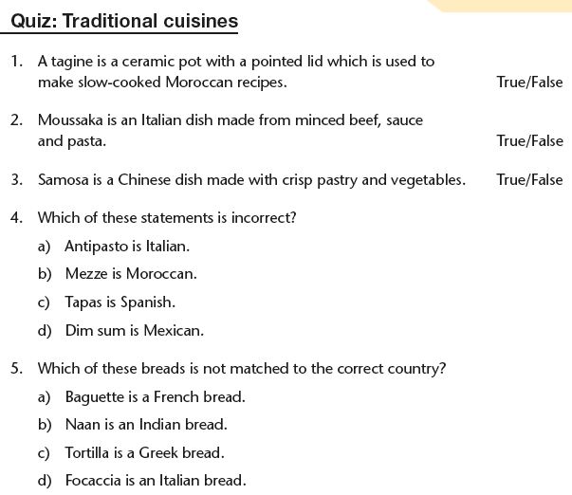
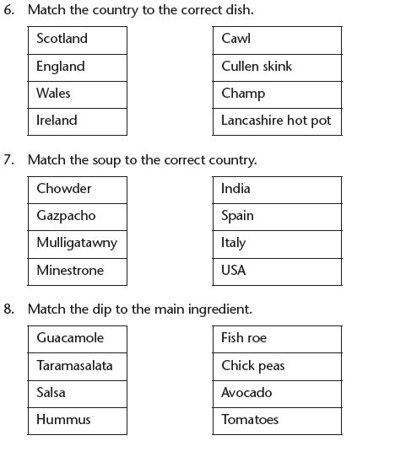
Finding out about pasta

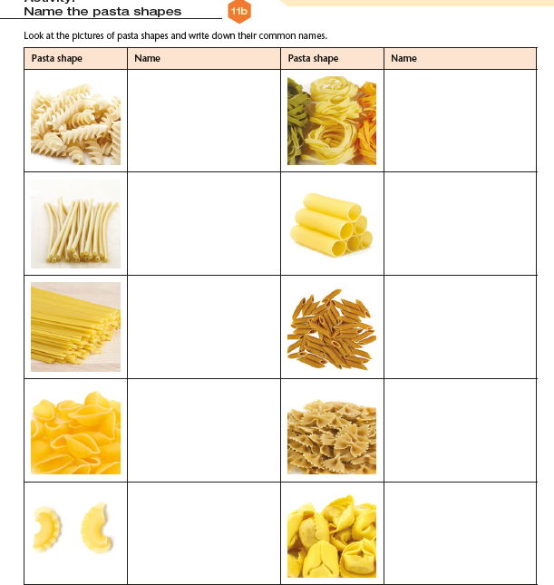

There are two main types of pasta, pasta _________ (fresh) and pasta ________ (dried); pasta that is resistant to bite (slightly firm) is called ____________. Italian style ______ pasta should always be made from _______ wheat flour or semolina (a more coarsely ground _____). Durum wheat is _____ in ______, the substance which makes the dough ________; when combined with water makes a firm easily shaped ______. The machine that makes the shapes is called an _________.

Word Bank
Elastic, flour, fresca, high, dough, secca, gluten, durum, aldenté, dried, extruder

A closer look at Italy

Pasta is associated with Italy but is very popular in the UK too. As a multicultural society, we have adopted many other Italian cultural influences. Complete this worksheet to test your knowledge of Italy!
Pasta is a food that contains starch, a carbohydrate which provides energy for our bodies. It is a complex carbohydrate which means it releases the energy slowly into the body. Pasta especially wholemeal is a source of fibre.

Pasta can come in different flavours:
Green is flavoured with _________________________
Red is flavoured with ___________________________
Black is coloured with __________________________
Do you know your pasta sauces?
Match the name to the description.
1.Carbonara, 2. Bolognaise. 3. Napoletana 4. Arrabbiata
___ Chilli and tomato ____ Bacon and cream ___ Meat and tomato ___ Tomato and onion

Which one is a 1. Bread 2. Pasta 3. Cheese
Linguine ____ Pecorino ____ Tagliatelle ____ Mascarpone ____
Ciabatta ____ Fettucinne ____ Dolcelatte ____ Ravioli ____
Parmesan ____ Cannelloni ____ Mozzarella ____ Focaccia ____
Gran Padano ____ Spaghetti ____ Lasagne ____ Panini ____
Gorgonzola ____ Tortellini ____ Brushetta ____

Can you read an Italian menu?
- Minestone 2. Salami 3. Tiramusu 4. Risotto 5. Frittata
- Calamari 7. Scampi 8. Chianti 9. Panetonne
Wine ____ Trifle ____ Prawns ____ Fruit cake ___ Rice dish __
Omelette ____ Dried sausage ____ Soup ____ Squid ____

GENERAL KNOWLEDGE

Name an Italian football team.
Name a volcano that can be found in Italy.
What is the capital of Italy?
Who was Benito Mussolini?
Who was Luciano Pavarotti?
Name an Italian Formula One team
Where does the Pope reside?

Investigation into the viscocity of sauces
You will carry this investigation in groups
The investigations will change 1 variable at a time:

- Type of starch- plain flour, corn flour, arrowroot
- Ratio of starch: liquid -50g:500ml; 50g:250ml; 50g:125ml; 50g:50ml
- Using the same ratios; alter the stirring time: 1min; 5 mins;10 mins; 15mins
- DOES HEATING THE LIQUID HELP IT TO THICKEN?
- ADD THE STARCH AND LIQUID TO A SAUCEPAN IN THE RATIOS SUGGESTED AND HEAT.
- CONSIDER TIMINGS: DOES CHANGING THE TIME SPENT STIRRING MAKE A DIFFERENCE?

Appearance
Aroma
Texture
THICKNESS
Appearance
Aroma
Texture
THICKNESS

Appearance
Aroma
Texture
THICKNESS
Appearance
Aroma
Texture
THICKNESS

Appearance
Aroma
Texture
THICKNESS
Appearance
Aroma
Texture
THICKNESS

America is best known for ‘junk’ food such as hamburgers and fries. Complete the puzzle to see what other foods they have given us:

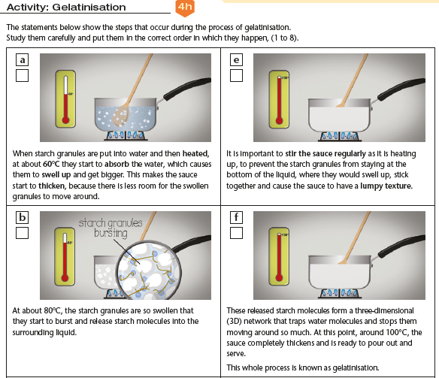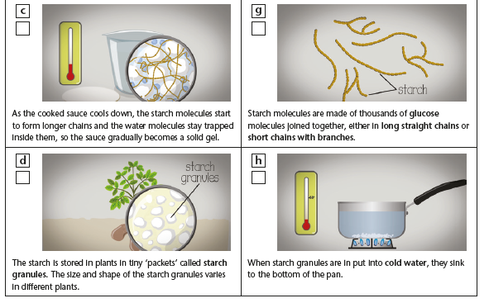

Sauces: exam questions
How could adaptations be made to overcome these criticisms made by a taste panel testing sauces:
- Too bland: ………………………………………………………………………..
………………………………………………………………………………………
- Too salty: ………………………………………………………………………….
………………………………………………………………………………………
- Too thick: …………………………………………………………………………
………………………………………………………………………………………
- Too runny: .……………………………………………………………………….
………………………………………………………………………………………
(8 marks)
List four food ingredients in a sauce you have studied and state their functions in the product.
………………………………………………………………………………………………………………………………………………………………………………………………………………………………………………………………………………………………………………………………………………………………………………………………………………………………………………………………………………………………………………………………………………………………………………………………………………………………………………………………………….
(8 marks)
In the production of a tomato based sauce, why is it desirable/necessary to remove the skins?
……………………………………………………………………………………………………………………………………………………………………………………………………………………………………………………………………………………………………………………………………
(2 marks)
You are planning you use a ready prepared sauce with chicken.
Name five sauces you could use.
……………………………………………………………………………………………………………………………………………………………………………………………………………………………………………………………………………………………………………………………………………………………………
(5 marks)

What other foods would you add to the chicken dish to complete the meal? Give a reason for each.
………………………………………………………………………………………………………………………………………………………………………………………………………………………………………………………………………………………………………………………………………………………………………………………………………………………………………………………………………………………………………………………………………………………
(2 marks)

Name an alternative to chicken in your dish and give one reason for your choice.
……………………………………………………………………………………………………………………………………………………………………………………………………………………………………………………………………………………………………………………………………………………………………
(2 marks)

What factors may influence a consumer when selecting ready prepared sauces?
……………………………………………………………………………………………………………………………………………………………………………………………………………………………………………………………………………………………………………………………………………………………………
(3 marks)
Explain, with examples, how the needs of different cultures have been considered in the ready made sauce market. (4 marks)
……………………………………………………………………………………………………………………………………………………………………………. ………………………………………………………………………………………………………………………………………………………………………………………………………………………………………………………………………………………………………………………………………………………………………………………………………………………………………………………………………………………………………………………………………………………………………………………………………………………………………………………………………….
(4 marks)

/35
.
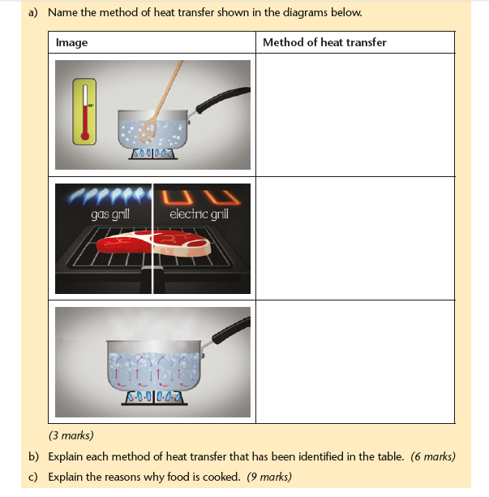

America is best known for ‘junk’ food such as hamburgers and fries. Complete the puzzle to see what other foods they have given us:
 | 1 |  |  | 2 |  |  |  |  |  |  |  | 
 |  |  |  | 3 |  |  |  |  |  |  |  |  |  | 4
 |  |  |  |  |  |  | 5 |  |  |  |  | 6
 |  |  |  | 7
 |  |  |  |  |  |  |  |  |  |  |  | 8
 |  |  | 9 |  |  |  | 10
11
Clues:
1 Down: a corn meal pancake actually from Mexico.
1 Across: without Columbus we would need a different bird for Christmas dinner.
2 Down: The full name for KFC is ………………………………… …………………………….. chicken.
3 Across: Again from Mexico, Corn chips with salsa and cheese.
4 Down: a salad made with cos lettuce, crispy croutons and Parmesan cheese.
5 Down: This syrup from Canada is eaten with 6 down.
6 Down: These are smaller and thicker than their European cousins.
7 Across: From a medicine to the world’s most popular soft drink.
8 Across: this vegetable is often eaten ‘on the cob’.
9 Across: A popular drink, can be strawberry, vanilla or chocolate flavour.
10 Down: This tinned meat was widely eaten during WWII.
11 Across: Canned and in tomato sauce, a vegetable eaten by children.
Why is it a concern that British people are eating more and more American style meals? ………………………………………………………………………………………………………………………
Evaluation

Food | Sensory description | Evaluation and country of origin
Cottage pie
Toad in the hole and onion gravy
Lasagne
Burritos
Greek kofta and tzatziki
Chicken chow mein
Thai curry
American brownies

Label the flags’ country

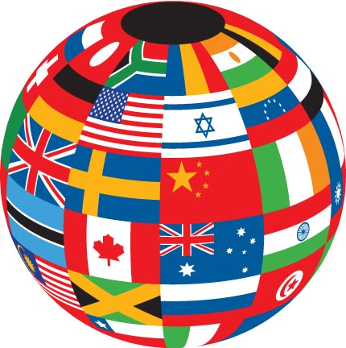
.

Year 9: ASK Yourself!
Subject: Food preparation and nutrition
Unit: Celebrating Society Project
 | Launching  1-2 | Developing  3-4 | Progressing  5-6 | Mastering  7-9
S

kills
Making main meals from a variety of cultures | I can make a range of products with assistance. | I can follow a recipe independently. | I can prepare a variety of dishes which are finished to a high standard. | I can modify a recipe and create an original idea.
Seasoning | I know which ingredients are from different cultures | I know how to flavour foods with a variety of cultural flavours | I can make and present 2 dishes without assistance which derive from British Culture. | I can make and present 4 dishes without assistance which derive from International Cultures.
K

nowledge
Understand Cultural differences | I understand British culture and can name 4 regional recipes. | I understand 1 other culture and can identify ingredients used in cooking from that culture. | I know that there are particular customs that are linked to different cultures | I can explain how cultural influences have altered the cuisine of the UK.
Sauces | I know that there is a variety of sauces available | I know the ingredients needed to make a roux sauce | I know what the functions of ingredients are in a roux sauce. | I can explain gelatinisation./.
Cooking methods | I can name 4 different cooking methods | I can name 2 methods of heat transfer | I can describe 4 methods of heat transfer | I can explain in detail how heat is transferred to food in 4 different cooking methods

