|  |  |
| --- | --- |
|  | @SBESCHOOL Sports Leadership Diploma |
|  |  |
|  | Name: ……………………………………………………..  Cohort: ……………………………………………………..  Teacher: …………………………………………………….. |

# Who am i?

List the organised, competitive sports or physical activities you have taken part in to date:

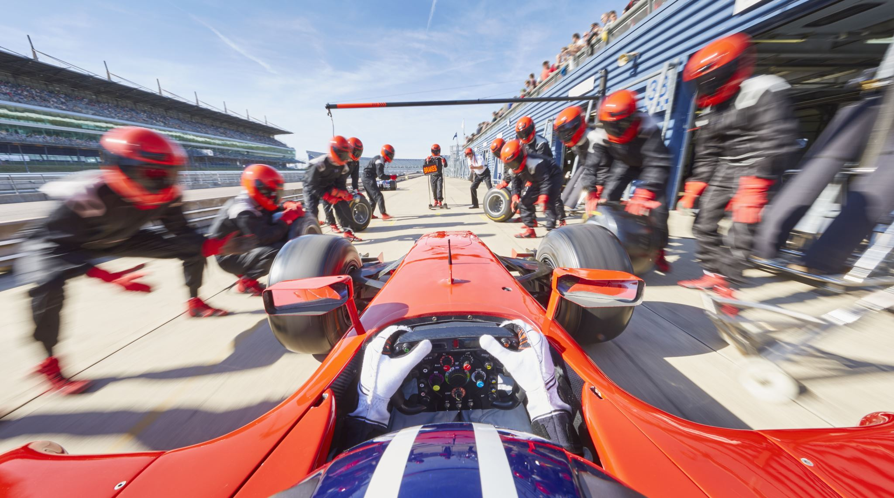

What is my active experience?



Describe your most memorable sporting achievement up to now:

­



“The quality of a **leader** is reflected in the **standards** they set for **themselves**”

­

You can be **great**, you can be a **success**, you can **inspire** others! But to do so you must **MAKE EFFORTS** to get the basics right.

At Shenley Brook End School we set **high expectations** for ourselves.

Within the Leadership Diploma, we **aspire** to be the ones who **lead by example**.

The Shenley Brook End Leadership Diploma Minimum Expectation Pledges:

**I WILL…** Come to my lesson **ON TIME** and **WELL-PREPARED**

**I WILL…** Use **RESPECTFUL WORDS ONLY** when communicating with staff or peers

**I WILL…** **TRY** and **TRY HARD** to complete all tasks set for me

This includes following the instructions of the staff members responsible for being in your lesson, without hesitation or argument (even if you don’t agree with them!)

I want to be a great leader and know how to meet the basic expectations of the course:

Name:…………………………. Signed:………………………. Date:………….

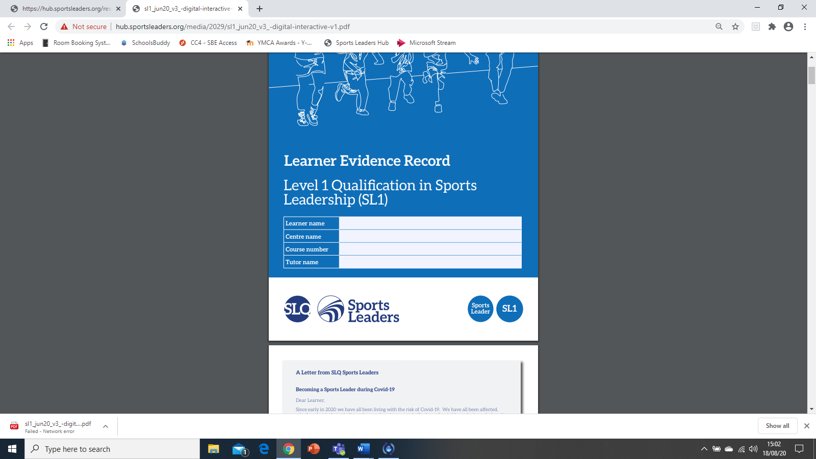

Why Sports Leadership Diploma?

This year you will be working under the learning framework provided in the SLQ Level 1 in Sports Leadership. You will undertake tasks and demonstrate your leadership skills in theory and practical situations. In exchange for your hard work and learning, you will receive:

* New skills and knowledge that can be used to develop yourself
* A Level 1 Sports Leaders Certificate
* The ability & competence to apply for a role supporting a more qualified leader in a paid coaching environment

**What are you most looking forward to achieving this year?**

How will I get there?

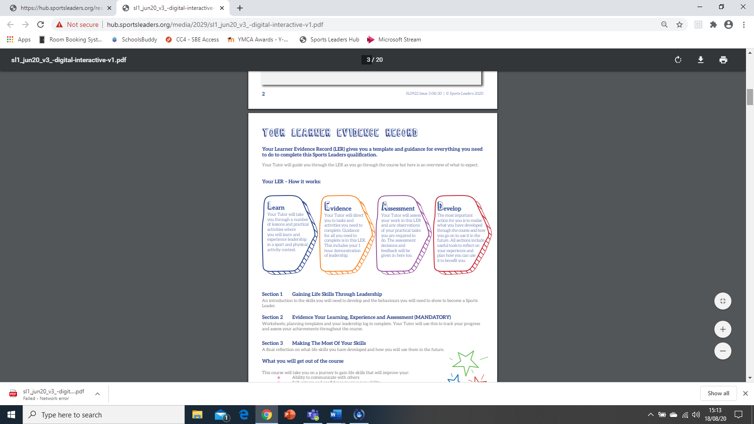

­

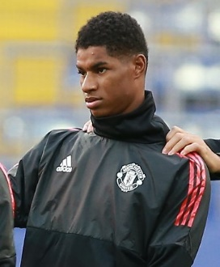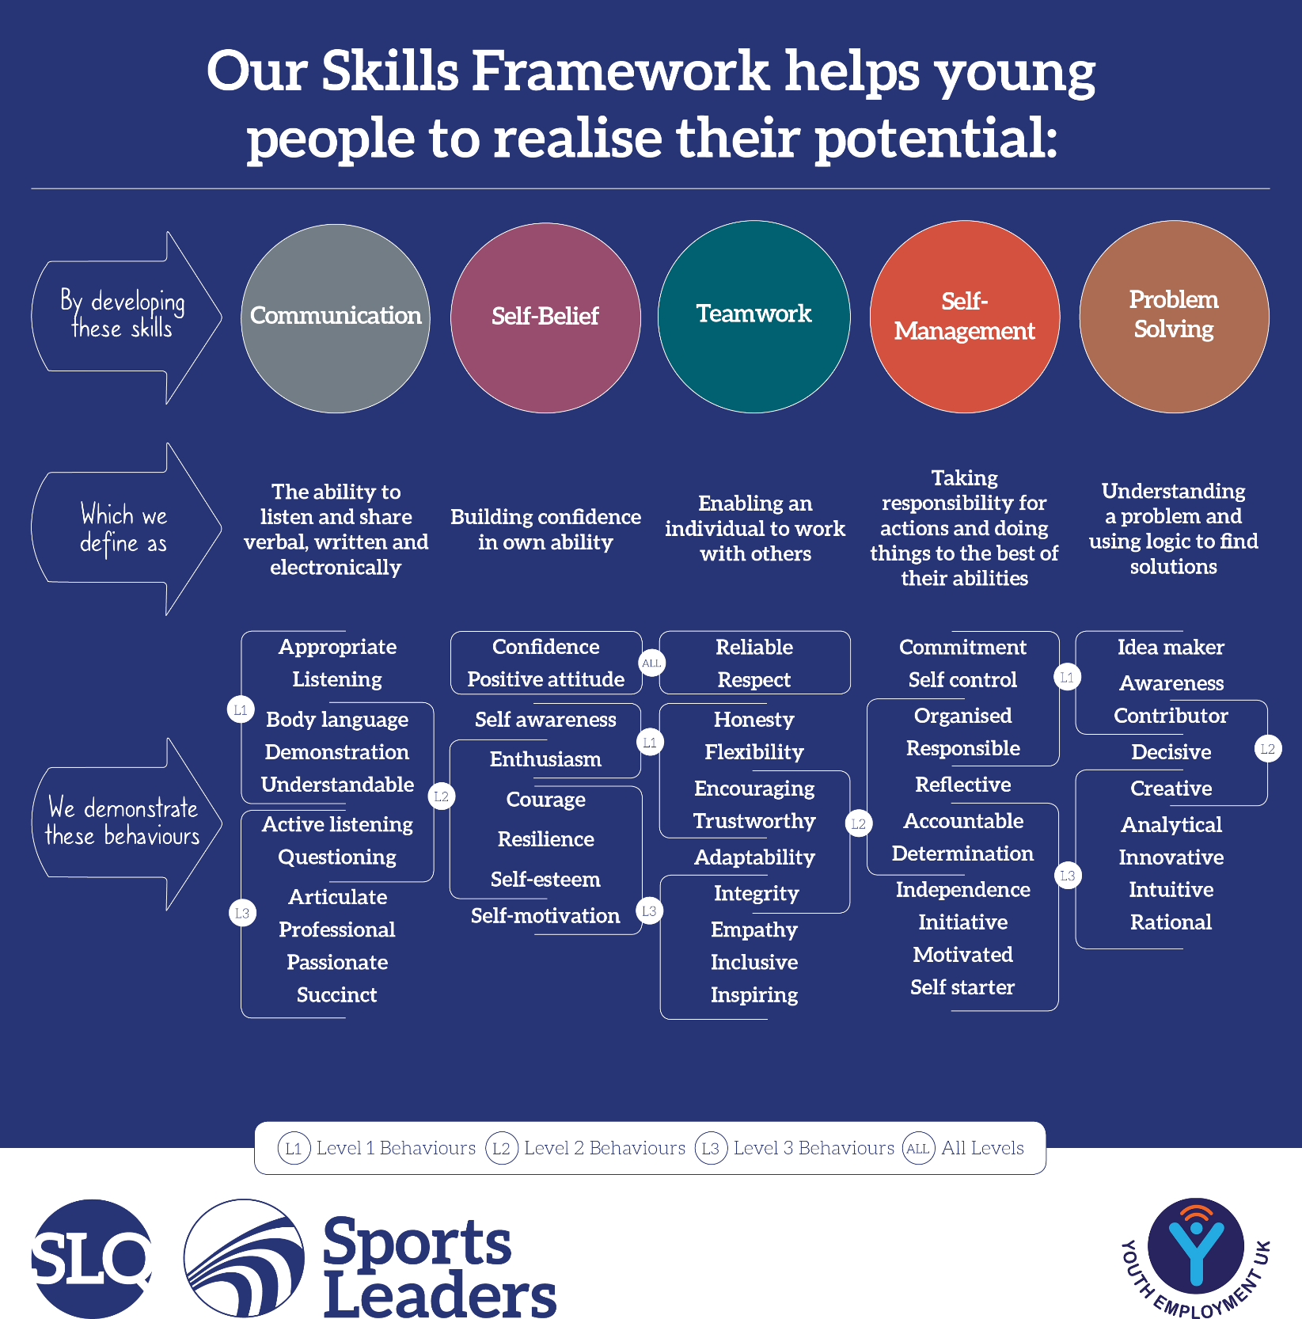

**REDUCE TASK**

Marcus Rashford has proven to be a valiant leader on and off the field. Which **one** of the skills listed above do you think he possesses the most?

Which one of the skills above so you think **you** currently show the most?

# Why Sport and Physical Activity?

Describe your game below – What rules did it have in place? How was the winner decided? Draw a diagram!



Game creation

You have been asked to create a game using minimal space and equipment.

The only things the game needed to be was competitive and active.

What did you consider to be important parts of your planning and creativity to ensure your game was great?

What makes sport and physical activity so enjoyable?

What

# What Makes a good Sports Leader?

Rate your teacher in your last lesson. Can you think of examples of them performing these roles well or badly?

**Organised:**

**Communication:**

**Enthusiasm:**

**Body Language:**

**Respectful:**

When leading a sport or activity there are a number of things that can go right or wrong depending on how the leader manages themselves.

Think of some great examples of the following skills and behaviours a leader would show at their best:

|  |  |  |  |  |
| --- | --- | --- | --- | --- |
| Enthusiastic | Listens | Confident | Patient | Respectful |
| Use of voice | Organised | Focus | Encouraging | Committed |

# Coach or coachable?

Feel free to add any more skills, qualities or behaviours of your own. Is the success and enjoyment of a sports or activity session **all** down to the leader?



Below are two outlines of people. On the left is the coach or leader. On the right is the player or participant.

Use the word bank below to identify which skills and behaviours are needed by which of the people for a session to run well

**Task 1.1**

**Leadership skills and behaviours**

There are 5 skills that can be thought of as the **key skills** that you’ll need as a Sports Leader. Each key skill will have certain **behaviours** that make it happen successfully. In the table below you must outline why these **key skills** and **associated behaviours** are important for a Sports Leader.

|  |  |  |  |
| --- | --- | --- | --- |
| **Key skill** | **Outline why this key skill is needed as a Sports Leader** | **Associated behaviours** | **Pick 2 behaviours and outline why they are needed as a Sports Leader** |
| **Communication** |  | - Appropriate  - Listening  - Body language  - Demonstration  - Understandable | 1) |
| 2) |
| **Self-belief** |  | * Confidence * Positive attitude * Self awareness * Enthusiasm | 1) |
| 2) |
| **Teamwork** |  | * Reliable * Respect * Honesty * Flexibility * Encouraging * Trustworthy | 1) |
| 2) |
| **Self- management** |  | * Commitment * Self control * Organised * Responsible | 1) |
| 2) |
| **Problem solving** |  | * Idea maker * Awareness * Contributor | 1) |
| 2) |

Skills: A skill is something that you can do e.g. communicating with others

Behaviours: What you need to show to make your skills more effective, e.g. being confident

**Task 1.2**

**Using leadership skills and behaviours in other environments**

The leadership skills and behaviours that you develop on this course will be useful in other areas of life, for example: with family, friends, in other subjects at school and outside school in clubs or other activities you do.

In the table below you must outline how the key skills and identified behaviours might be useful in other areas of your life, away from your PE lessons and sports leadership.

|  |  |
| --- | --- |
| **Key skills and behaviours** | **Outline the positive impact these may have on other areas of life** |
| **Communication** – being understood by others and listening to what they have to say |  |
| **Self-belief** – being confident and having a positive attitude |  |
| **Teamwork** – being reliable and respectful to other people |  |
| **Self-management** – showing commitment and being well organised |  |
| **Problem solving** – having ideas and sharing them with others |  |

In the table below you must outline the main responsibilities, and say how the key skills and behaviours will be needed to fulfil the identified roles. Each role has different responsibilities and the key skills and behaviours that you have learnt about will be vital if you are to fulfil these roles successfully.

|  |  |  |  |
| --- | --- | --- | --- |
| **Role** | **Responsibilities** | **Key skills** | **Behaviours** |
| Referee/Umpire |  |  |  |
| Safety Officer |  |  |  |
| Scorer/Timekeeper |  |  |  |
| Manager |  |  |  |
| Coach |  |  |  |

**Task 1.3**

**Reflecting on the leadership skills you have used**

In order to improve anything, it is important to think about where you are now, where you would like to be and how you plan to get there. Use the table below to rate your current key skills as a Sports Leader, then consider how these skills might be improved. You can reflect back at the end of your course to see how successful this development plan was and how much improvement there has been in your key skills.

|  |  |  |  |  |  |  |  |  |  |  |
| --- | --- | --- | --- | --- | --- | --- | --- | --- | --- | --- |
| **Key skills** | **Score at start of course**\* | | | | **What will you do on the course that will help you improve these key skills?** | **Score at end of course**\* | | | | **How successful was your development plan?** |
| **1** | **2** | **3** | **4** | **1** | **2** | **3** | **4** |
| **Communication** |  |  |  |  |  |  |  |  |  |  |
| **Self-belief** |  |  |  |  |  |  |  |  |  |  |
| **Teamwork** |  |  |  |  |  |  |  |  |  |  |
| **Self- management** |  |  |  |  |  |  |  |  |  |  |
| **Problem solving** |  |  |  |  |  |  |  |  |  |  |

* 1=Low and 4=High

|  |  |  |  |  |
| --- | --- | --- | --- | --- |
| **Mandatory for the Tutor/ Assessor (T/A) to complete** | | **Defer Date** (if required) | **Pass Date** | **Comments by the T/A supporting the assessment decisions against all Tasks. If an assessment decision is deferred, the T/A must detail additional requirements set and achieved by the learner.** |
| Task 1.1 | |  |  |  |
| Task 1.2 | |  |  |
| Task 1.3 | |  |  |
| Signature |  | Date |  |

# How to lead a Warm-Up

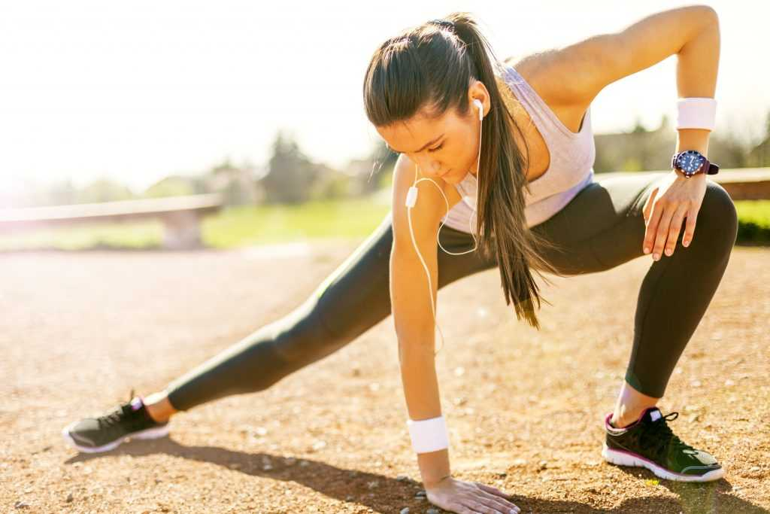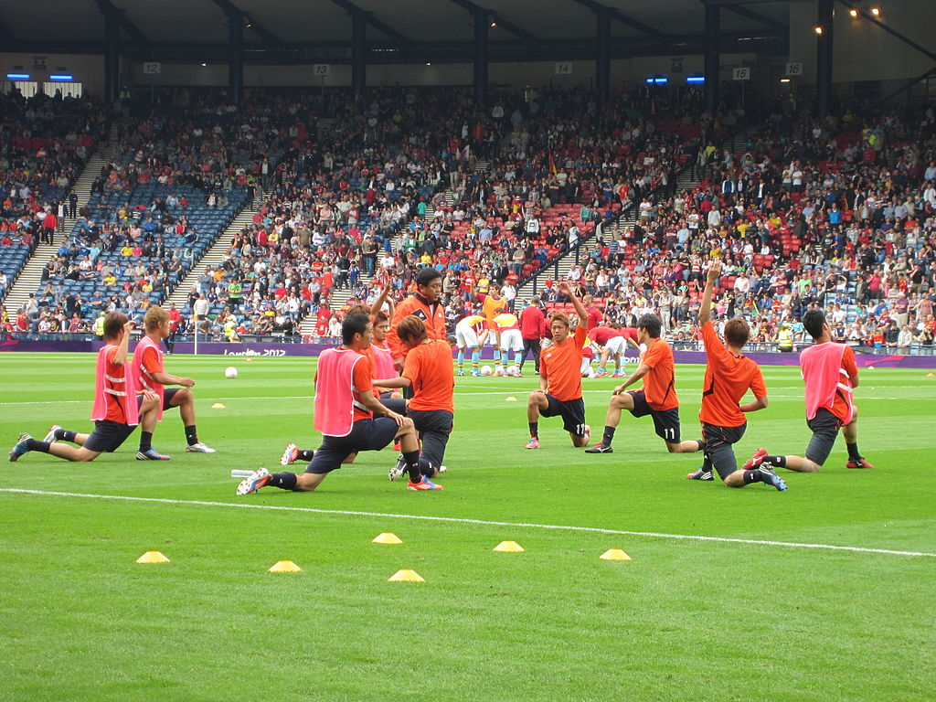

Warm-ups are important and usually happen at the **start** of any sport or physical activity session.

Often, the coach will look to use the warm-up time to **get organised**, perhaps setting out cones or taking a register.

But its vitally important that the warm-up is done **correctly** to ensure that the participants are **prepared** for the activities they are about to undertake.

This will ensure they **lower the risk of injury** and **increase the chances of positive physical and mental performance.**

**Three stages of a warm-up:**

**1. Pulse-Raiser**

**2. Stretching (Static and Dynamic) and Joint Mobilisation**

**3. Sport-Specific Activity**

**The three main benefits of a proper warm-up before physical activity are:**

**1.**

**2.**

**3.**

# Warm-Ups – The Pulse RaiserPulSE Raiser 2

My favourite, “Go-To” pulse raiser when coaching children is (describe and explain – Use a diagram):

For elite athletes – the pulse raiser will be professional and purposeful – usually involving a jog, run, swim or cycle to get the HR up quickly.

For children, it’s a great opportunity to involve a bit of fun and silliness. Getting them enthusiastic about the activities to come.

You will know when the pulse-raiser is complete due to:

Increase in ____________________

Increase in ____________________

Raised body temperature which may show as __________

The purpose of a pulse raiser is mainly to ensure you are sending a sufficient supply of _____________ to your ____________.

As the body moves, the _________ will start to work harder, pumping more _________ around the body to the areas that are demanding it the most.

Having more oxygen present allows for more _________ to be produced and replenished which will be needed during the physical activity.

*Heart, Oxygen, Energy, Blood, Muscles*

A great pulse raiser for year 2 & below is:

A great pulse raiser for more serious team sports is:

A great pulse raiser for individual sports (gymnastics, dance, athletics) children is:

# Stretching & Joint Mobilisation

|  |  |  |  |  |  |
| --- | --- | --- | --- | --- | --- |
| High Kick | Ankle Roll | Shoulder Circles | Open The Gate | Grapevines | Shrugs |
| Close The Gate | Neck Rotation | High Knees | Side Leans | Trunk Twists | Wrist Rotations |

**Write each dynamic stretch / joint mobilisation in the appropriate section**

Lower Body

Upper Body

## Quick-Fire Quiz

1. Once the pulse-raiser is complete, the body’s temperature should have raised. This, and the additional blood flow to the area, will make muscles more:

2. Which type of stretching would come first – Dynamic or Static?

3. How long should we hold each static stretch for?

Stretching takes two forms – Dynamic (stretching whilst on the move) and static (stretching when remaining still).

It is very important to get stretching correct as it may well lead to further injury if not completed correctly.

|  |  |  |
| --- | --- | --- |
| Static Stretches for the Upper Body | | |
|  |  |  |
|  |  |  |
| Static Stretches for the LOWER Body | | |
|  |  |  |
|  |  |  |

# Stretching & Joint Mobilisation

# Single Practical Activity Plan

|  |  |  |  |  |
| --- | --- | --- | --- | --- |
| **Group Members:** | | | | |
| **Date of session** | **Time and duration** | **Participants (who, number, age/ability, etc.)** | | |
|  |  |  | |
| **Focus/aim of activity** | | **Topic/sport/activity** | | |
|  | |  | |
| **Key Covid-19 guidance for this session** | | **Who is responsible for managing the Covid-19 guidance? (i.e. your supervisor)** | | |
|  | |  | |
| **Facilities/working space/environment** | | **Equipment list** | | |
|  | |  | |
| **Name and description of activity**  Use written descriptions and/or diagrams | | | **Adaptation**  Suggest 1 change to make each activity more/ less challenging | |
|  | | |  | |
|  | |

# Reflection Time

|  |  |
| --- | --- |
| **Review of the activity** | |
| **What went well?** | **How did you review the session?** |
|  |  |
| **What needs more work?** | **What will you change for next time?** |
|  |  |

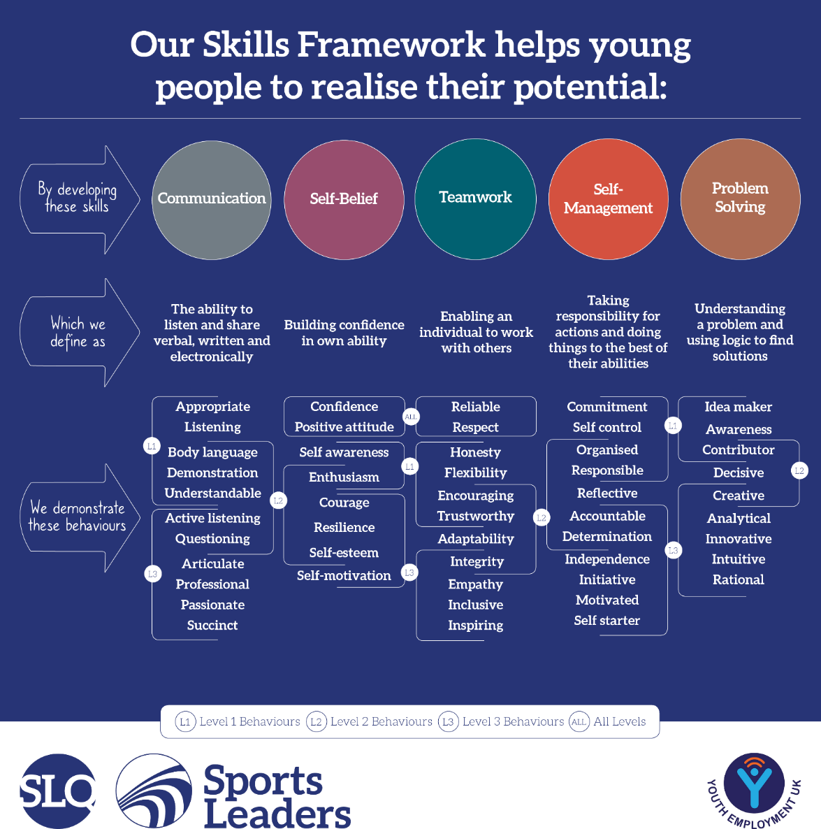So how did it go?

Nobody is perfect and even a session that was enjoyable and felt great will have some area for improvement.

Well done if you managed to deliver your first activity!

To ensure we learn from our experiences and develop our leadership ability through practice, it is useful to use a process to reflect:

**PLAN**

**DO**

**REVIEW**