Leadership Diploma Qualification

Name: …………………………………………………….
Group: ……………………………………………………
Teacher: …………………………………………………
A drawing of me as an excellent sports leader
Term E –
Tag Rugby Leaders Award
Term F –
Student Led Tournaments
Term D –
Living For Sport
Term C –
Officiating & Primary School Festival
Term B –
Inclusive Activities
Term A –
Key Skills of a Leader

Why Sports Leadership Diploma?
This year you will be working under the learning framework provided in the SLQ Level 1 in Sports Leadership. You will undertake tasks and demonstrate your leadership skills in theory and practical situations. In exchange for your hard work and learning, you will receive:
- New skills and knowledge that can be used to develop yourself
- A Level 1 Sports Leaders Certificate
- The ability & competence to apply for a role supporting a more qualified leader in a paid coaching environment
What are you most looking forward to achieving this year?

How will I get there?

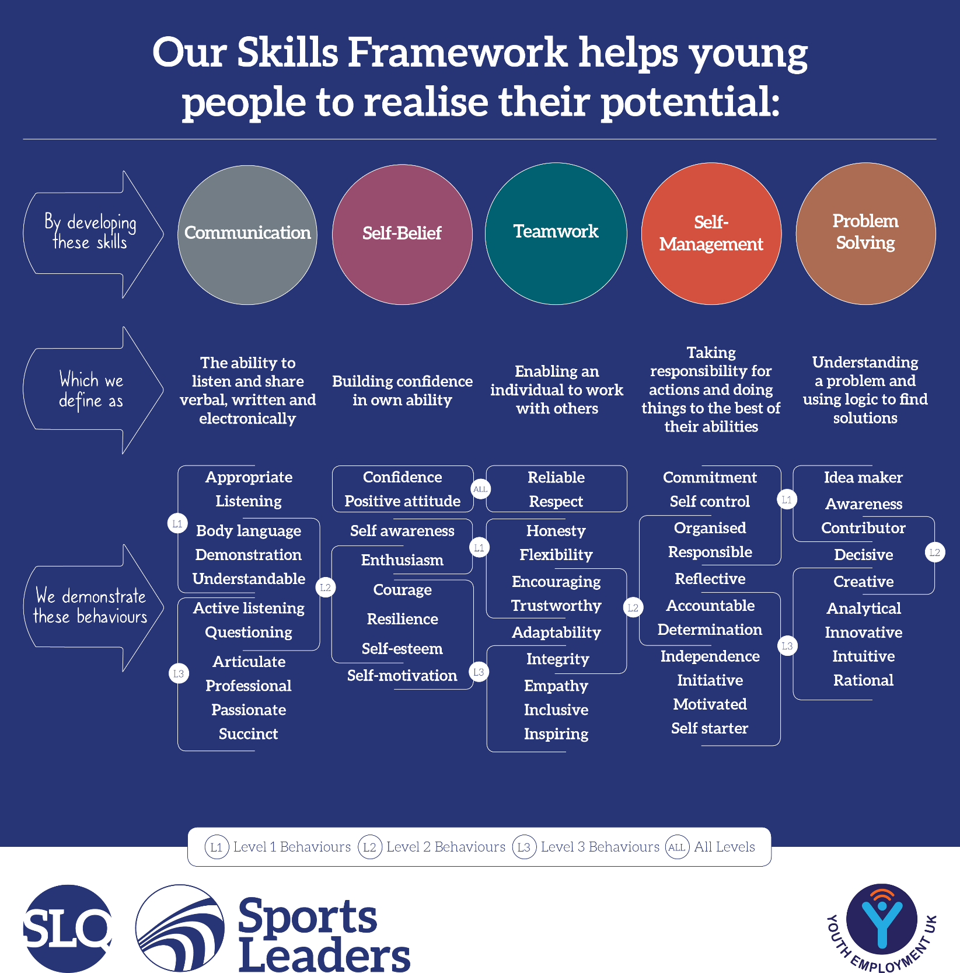
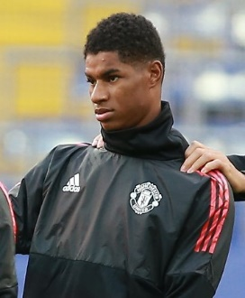
REDUCE TASK
Marcus Rashford has proven to be a valiant leader on and off the field. Which one of the skills listed above do you think he possesses the most?
Which one of the skills above so you think you currently show the most?

Term A -
Key Skills of a Leader
Term A - Theory Lesson 1
Pick 5 skills and place them in the diagram below. Rate yourself from 1 – 5 on how well you currently display that skill.

Term A - Theory Lesson 2
What is the difference in leadership style between the following people?

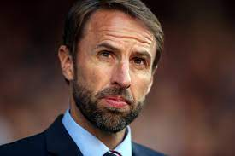
Gareth Southgate – England Football Manager
Dina Asher Smith – GB Athlete and Role Model
Owen Farrell – England Rugby Captain

Good leader Bingo

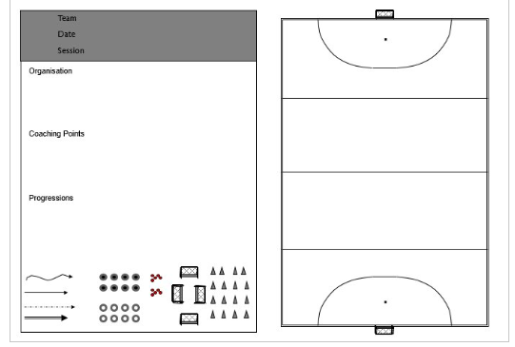
Term A – Theory Lesson 3
Term B –
Inclusive Activities
Term B – Theory Lesson 1
Complete the acronyms below for the 3 methods.

TREE Method
TREE

STEP Method/Framework
STEP

CHANGE IT Method
CHANGE
I T
Term B – Theory Lesson 2
Person A’s drawing Person B’s drawing

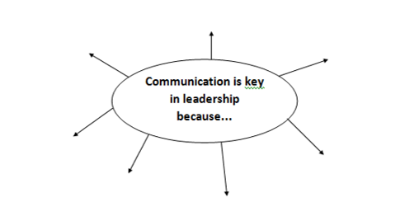

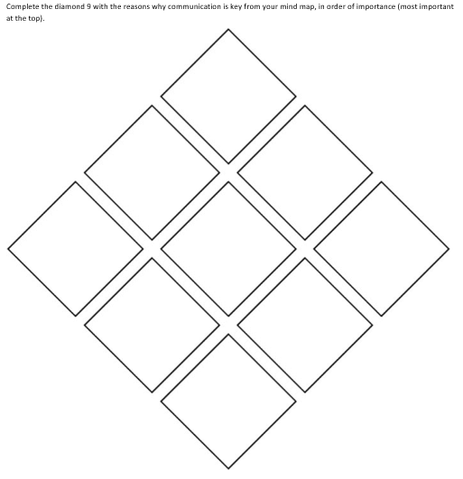

Term B – Theory Lesson 3
Group Members:
Date of session | Time and duration | Participants (who, number, age/ability, etc.)
Focus/aim of activity |  | Topic/sport/activity
Key Covid-19 guidance for this session |  | Who is responsible for managing the Covid-19 guidance? (i.e. your supervisor)
Facilities/working space/environment |  | Equipment list
Name and description of activity  Use written descriptions and/or diagrams |  |  | Adaptation  Suggest 1 change to make each activity more/ less challenging

Term B – Theory Lesson 4
Nobody is perfect and even a session that was enjoyable and felt great will have some area for improvement.
Well done if you managed to deliver your first activity!
To ensure we learn from our experiences and develop our leadership ability through practice, it is useful to use a process to reflect:
PLAN
DO
REVIEW

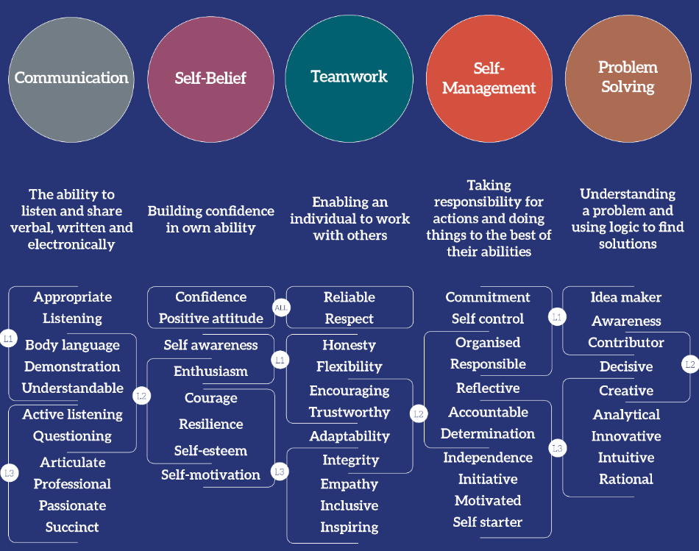

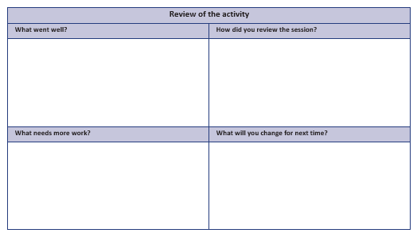

Term C –
Officiating & Primary School Festival
Term C – Theory Lesson 1
Notes space for information found on your chosen officiating sport

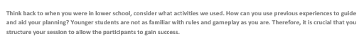
Term C – Theory Lesson 2

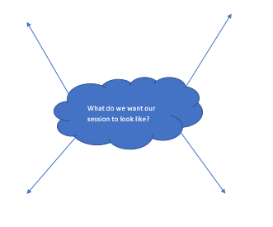
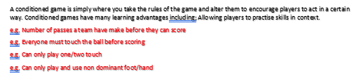
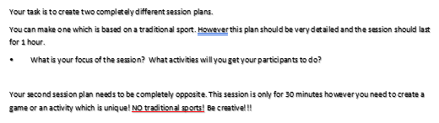
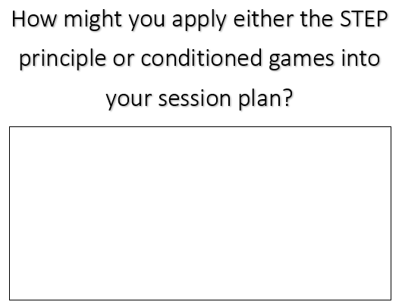
Traditional plan
Group Members:
Date of session | Time and duration | Participants (who, number, age/ability, etc.)
Focus/aim of activity |  | Topic/sport/activity
Key Covid-19 guidance for this session |  | Who is responsible for managing the Covid-19 guidance? (i.e. your supervisor)
Facilities/working space/environment |  | Equipment list
Name and description of activity  Use written descriptions and/or diagrams |  |  | Adaptation  Suggest 1 change to make each activity more/ less challenging

Unique sport plan
Group Members:
Date of session | Time and duration | Participants (who, number, age/ability, etc.)
Focus/aim of activity |  | Topic/sport/activity
Key Covid-19 guidance for this session |  | Who is responsible for managing the Covid-19 guidance? (i.e. your supervisor)
Facilities/working space/environment |  | Equipment list
Name and description of activity  Use written descriptions and/or diagrams |  |  | Adaptation  Suggest 1 change to make each activity more/ less challenging

Term C – Theory Lesson 3

Term D –
Living For Sport
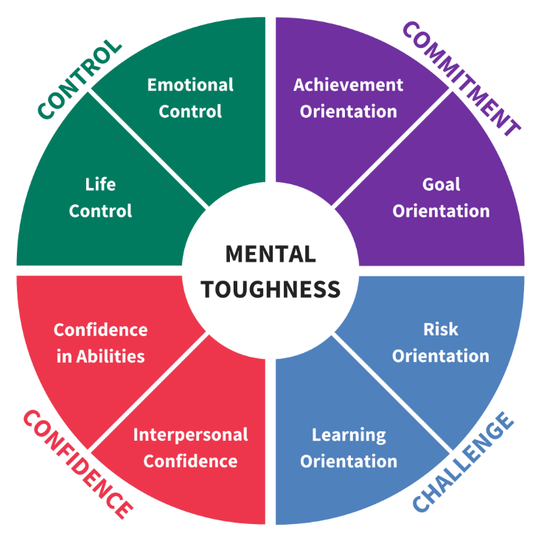
Term D - Theory Lesson 1
Rank the following, in your opinion, from most important to least important in terms of being mentally tough.
1.
Explain your reasoning here for your top 2 and bottom 2…
8.
7.
6.
5.
4.
3.
2.
Term D – Theory Lesson 2
Complete the Venn diagram for mental toughness and hunger to achieve.

Term D – Theory Lesson 3
What potential barriers could the following groups of people have in sport?
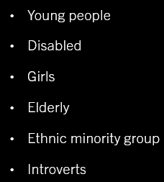

Term E –
Tag Rugby Leaders Award
Term E – Theory Lessons

Notes and planning section

Group Members:
Date of session | Time and duration | Participants (who, number, age/ability, etc.)
Focus/aim of activity |  | Topic/sport/activity
Key Covid-19 guidance for this session |  | Who is responsible for managing the Covid-19 guidance? (i.e. your supervisor)
Facilities/working space/environment |  | Equipment list
Name and description of activity  Use written descriptions and/or diagrams |  |  | Adaptation  Suggest 1 change to make each activity more/ less challenging

Term F –
Student Led Tournaments
Term F – Theory Lesson 1
Competition Types Activity
Rules:

Scores & Results:

Events
From watching the ‘Sports Day at School’ video, make a list of the different activities you see:
______________________________________________________________________________________________________________________________________________________________________________________________________________________________________________________________________________________________________________________________________________________________________________________________________________________________________________________________________________________________________________________________________________________________________________________________________________________________________________________

Questionnaire planning

Term F – Theory Lesson 2
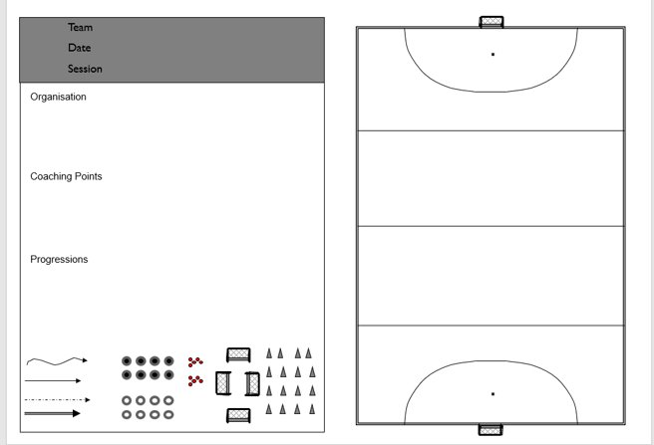

Tournament notes section for planning

Term F – Theory Lesson 3
Starter: write down as many sports tournaments as you can think of…

Findings and planning of how to present findings

