Worksheet 2A: The work of others

**Task 1 Investigation and analysis**

1. An *investigation* into a product or designer will usually focus on gathering facts based on a variety of criteria, including the materials used, processes involved in manufacture and the function of the designs.

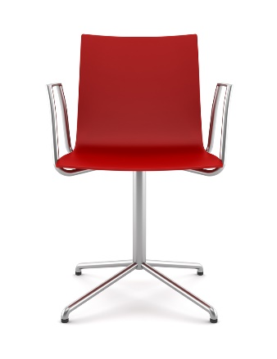Look at the three chairs below:

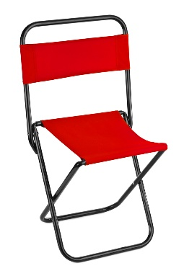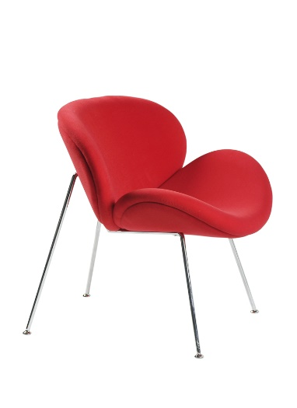

Using different criteria, investigate how each chair differs in its characteristics and fitness for purpose?

1. An *analysis* involves comparing and contrasting the information discovered during the investigation.
2. Suggest what type of person would own each of these chairs.
3. What do the chairs say about their owners?
4. How does each chair differ in functionality / aesthetics / materials?
5. Where would you expect to find each type of chair?

**Task 2 Evaluation**

1. *Evaluation* describes the process of drawing conclusions from the findings of   
   your investigation and analysis to determine the merit or significance of something   
   or someone.

Evaluate the effectiveness of each chair and suggest which features you might include in your own chair design, if you were asked to create one.

**Task 3**

Ettore Sottsass started the unconventional or rule-breaking design movement “Memphis”.



*A graphic based on the Memphis style*

Which other designers were rebellious? Justify your reasoning.