Year 9
Cambridge National
Options Booklet

Name:……………………………………………

Form:…………………………………………….

PE Teacher:……………………………………

Units

- Technology in Sport
- Reducing the Risk of Sports Injuries
- Applying Principles of Training
- Sports Psychology
- Sports Leadership
- Contemporary Issues in Sport
- Sport and the Media
- Developing Sports Skills

Technology in Sport

In this unit, you will begin to understand how technology is used in sport in innovative ways, with the aim of positively affecting the people making use of it.
Professional sport involves vast sums of money – both in terms of amounts being invested and amounts available for successful performance –so you can start to understand the role that technology plays in attempting to provide performers with a range of advantages.
You will also learn how technology affects coaches, officials and spectators during game play and at other times. You will gain knowledge and understand about how technology can be deemed to provide both advantages and disadvantages to all involved in sport.

Learning Outcome 1: Know how technology is used in sport
Learning Outcome 2: Understand the positive effects of sports technology
Learning Outcome 3: Understand the negative effects of sports technology
Learning Outcome 4: Be able to evaluate the impact of technology in sport

Learning Outcome 1: Know how technology is used in sport.
Task: Complete each of the 3 mind maps with sporting examples of technology and how they enhance performance, game play or spectatorship.

Enhance Performance

Enhance Game Play

Enhance Spectatorship

Learning Outcome 2: Understand the positive effects of sports technology
Learning Outcome 3: Understand the negative effects of sports technology
Task: Colour code the statements below as either green for it being a positive effect or red for it being a negative effect of sports technology.

Increases competition
Deterioration of skill

Rule and regulation changes
Game duration

Equipment is easier to use
Improved training aids

Ethics
See all the action

Learning Outcome 4: Be able to evaluate the impact of technology in sport
Task: Briefly describe the impact of VAR, Hawkeye, DRS and TMO on spectatorship.

Impact of VAR on spectatorship: ____________________________________________________________________________________________________________________________________________________________________________________________________________________________________________________________

Impact of Hawkeye on spectatorship: ____________________________________________________________________________________________________________________________________________________________________________________________________________________________________________________________

Impact of DRS on spectatorship: ____________________________________________________________________________________________________________________________________________________________________________________________________________________________________________________________

Impact of TMO on spectatorship: ____________________________________________________________________________________________________________________________________________________________________________________________________________________________________________________________

Extra space:
__________________________________________________________________________________________________________________________________________________________________________________________________________________________________________________________________________________________________________________________________________________________________________________________

Reducing the Risk of Sports Injuries

People working in sport and leisure industries need to be aware of the possibility of injury through involvement in sport and physical activity. Knowing how to reduce the risk of injury when taking part in sport, and how to respond to injuries and medical conditions in a sport setting, are important skills.
This unit looks at how to prepare performers for taking part in physical activity so that the risk of injury is minimised. It also describes how to respond to common sports injuries and how to recognise the symptoms of some common medical conditions, providing a solid foundation for those interested in more formal first-aid training and qualifications.

Learning Outcome 1: Understand different factors, which influence the risk of injury
Learning Outcome 2: Understand how appropriate warm up and cool down routines can help to prevent injury
Learning Outcome 3: Know how to respond to injuries within a sporting context
Learning Outcome 4: Know how to respond to common medical conditions

Learning Outcome 1: Understand different factors, which influence the risk of injury
Task: Complete the definitions for intrinsic and extrinsic factors and then add examples of each to the relevant mind maps.

Intrinsic factors: ____________________________________________________________________________________________________________________________________________________________________________________________________________________________________________________________

Extrinsic factors: ____________________________________________________________________________________________________________________________________________________________________________________________________________________________________________________________

Examples of Intrinsic factors

Examples of Extrinsic factors

Learning Outcome 2: Understand how appropriate warm up and cool down routines can help to prevent injury
Task: Complete the tables with the physical and psychological benefits of a warm-up and the components of a warm-up and cool down.

Physical Benefits | Psychological Benefits

Components of
Warm Up | Cool Down

Learning Outcome 3: Know how to respond to injuries within a sporting context
Task: Complete the following with the key terminology for SALTAPS and RICE.

S -
A -
L -
T -
A -
P -
S -

R -
I -
C -
E -

Learning Outcome 4: Know how to respond to common medical conditions
Task: Complete the blanks in the table of common medical conditions.

Name of condition | Examples of Symptoms | Treatment
 | Coughing, wheezing, shortness of breath | Use an inhaler/pump
Diabetes
 | Increased thirst, high or low sugar levels, extreme tiredness

Applying Principles of Training

By completing this unit, you will appreciate how coaches strive to keep their performers in peak condition and why this is important. The content covered includes how varying fitness tests are conducted and how the data gained from these tests can be used in the design of suitable and appropriate training programmes.
In learning about training programmes, you will appreciate the importance of the principles of training and how these principles can be applied to suit the individual needs and sports being performed. You will understand how training can be designed and implemented to allow performers to reach their performance targets.

Learning Outcome 1: Know the principles of training in a sporting context
Learning Outcome 2: Know how training methods target different fitness components
Learning Outcome 3: Be able to conduct fitness tests
Learning Outcome 4: Be able to develop fitness-training programmes

Learning Outcome 1: Know the principles of training in a sporting context
Task: Complete the table with sporting examples for the principles of training.

Principles of Training |  | Sporting Examples
Progressive Overload | Frequency
 | Intensity
 | Time
 | Type
 | Adherence
Specificity
Reversibility / Regression
Moderation
Variance

Learning Outcome 2: Know how training methods target different fitness components
Task: Place the following sports into the correct column based on whether they are aerobic and anaerobic forms of exercise.

Aerobic – With oxygen
Anaerobic – Without oxygen
Aerobic | Anaerobic

Walking  Speed skating | Weightlifting  Rowing | Cycling  HITT workout | Swimming  Shot Put

Learning Outcome 3: Be able to conduct fitness tests
Task: Describe in detail a test, which you have delivered or carried out in class and then use the table to analyse how you know which participant performed the 1-minute press up test the best.
Fitness test: ________________________________________________________________________________________________________________________________________________________________________________________________________________________________________________________________________________________________________________________________________________________________________________________________________________________________________________________________________________________________________________________

Participants Data –
Olly  Male  Age: 22 | Louisa  Female  Age: 15 | Zeke  Male  Age: 41
1 Minute Press up Test - 54 | 1 Minute Press up Test - 26 | 1 Minute Press up Test - 36

1-Minute Press Up Test Normative Data –
Scoring – The score is how many full press-ups are completed in one minute.
Age | 20 - 29 |  | 30 - 39 |  | 40 - 49 |  | 50 - 59 |  | 60+
 | Men | Women | Men | Women | Men | Women | Men | Women | Men | Women
Excellent | >54 | >48 | >44 | >39 | >39 | >34 | >34 | >29 | >29 | >19
Good | 45-54 | 34-48 | 35-44 | 25-39 | 30-39 | 20-34 | 25-34 | 15-29 | 20-29 | 5-19
Average | 35-44 | 17-33 | 25-34 | 12-24 | 20-29 | 8-19 | 15-24 | 6-14 | 10-19 | 3-4
Poor | 20-34 | 6-16 | 15-24 | 4-11 | 12-19 | 3-7 | 8-14 | 2-5 | 5-9 | 1-2
Very Poor | <20 | <6 | <15 | <4 | <12 | <3 | <8 | <2 | <5 | <1

Analysis: ___________________________________________________________________________________________________________________________________________________________________________________________________________________________________________________________________________________________________________________________

Learning Outcome 4: Be able to develop fitness-training programmes
Task: Complete the Health and Fitness section of the PAR-Q form.

Your Health Goals
- What health goals would you like to achieve in the next 3 months?

- Name 3 things you could do in order to improve your health.

What are your main reasons for starting a fitness programme? (Tick all that apply)
How would you describe your general health and fitness?
_______________________________________________________________
Have you ever done any structured exercises? Yes/No

If ‘yes’ what did you do? _______________________________________

What type of exercise do you enjoy the most? __________________________

What type of exercise do you dislike the most? __________________________

Sports Psychology

Within this unit, you will start to appreciate some of the finer details that make a difference in determining the success or failure of a performer. By identifying and exploring the many psychological factors that affect performance, you will gain knowledge and understanding of how such factors can be controlled and/ or used to provide an advantage.
Factors to be studied include different personality types, increasing motivation, and the effect of aggression. Further study will investigate: the effects of varying levels of arousal and anxiety; setting appropriate, SMART motivational goals; and how to use relaxation techniques to remain calm, focused and at optimal performance levels.
The unit will allow you to develop your knowledge and understanding of some of the psychological strategies and techniques that can be used in pursuit of excellence.

Learning Outcome 1: Understand the relationship between personality and sports performance
Learning Outcome 2: Know how motivation can affect sports performance
Learning Outcome 3: Know how aggression can affect sports performance
Learning Outcome 4: Understand the impact of arousal and anxiety on sports performance
Learning Outcome 5: Be able to apply sports psychology strategies to enhance sports performance

Learning Outcome 1: Understand the relationship between personality and sports performance
Task: For the extrovert and introvert mind maps, include traits of each personality type and examples of ‘preferred’ sports for each.

Extrovert Personality

Introvert Personality

Learning Outcome 2: Know how motivation can affect sports performance
Learning Outcome 3: Know how aggression can affect sports performance
Task: Complete the mind maps on types of motivation and implications on performance of aggression as well as the table on need to achieve and need to avoid failure.

Types of Motivation

Need to Achieve (NACH) | Need to Avoid Failure (NAF)

Implications on performance

Learning Outcome 4: Understand the impact of arousal and anxiety on sports performance
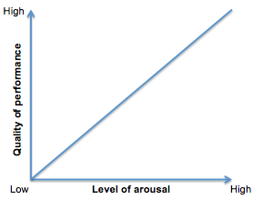
Task: Name the graph below and then write a couple of sentences to describe the conclusions that can be made from it.
___________________________________________________________________________________________________________________________________________________________________________________________________________________________________________________________________________________________________________________________
Learning Outcome 5: Be able to apply sports psychology strategies to enhance sports performance
Task: Write out the key terminology for a Smart target and then set a SMART target for yourself in any sport of your choosing.

S -
M -
A -
R -
T -
____________________________________________________________________________________________________________________________________________________________________________________________________________________________________________________________
Sports Leadership

Within this unit, you will begin to understand the important roles that sports leaders have in influencing those around them. The unit will give learners the opportunity to experience, first-hand, the knowledge, understanding and practical skills required to be an effective leader in sport. Learners are encouraged to consider and evaluate delivery of sporting activity sessions, focusing on their leadership styles, effective communication and personal behaviour conductive to being an effective leader. Learners will be given the opportunity to practically demonstrate and be adaptive in situations to enable them to meet the needs of the performers they are leading.

Learning Outcome 1: Know the personal qualities, styles, roles and responsibilities associated with effective sports leadership
Learning Outcome 2: Be able to plan sports activity sessions
Learning Outcome 3: Be able to deliver sports activity session
Learning Outcome 4: Be able to evaluate own performance in delivering a sports activity session

Learning Outcome 1: Know the personal qualities, styles, roles and responsibilities associated with effective sports leadership
Task: Compare and Contrast
A sports leader could be:
- Coach
- Team manager
- Captains
- Teachers
- Expedition leaders
- Role models
Choose two sports leaders of your choice. You need to list the differences and similarities the two leaders have. Any similarities the two leaders share should be placed in the middle section of the two leaders' circles.

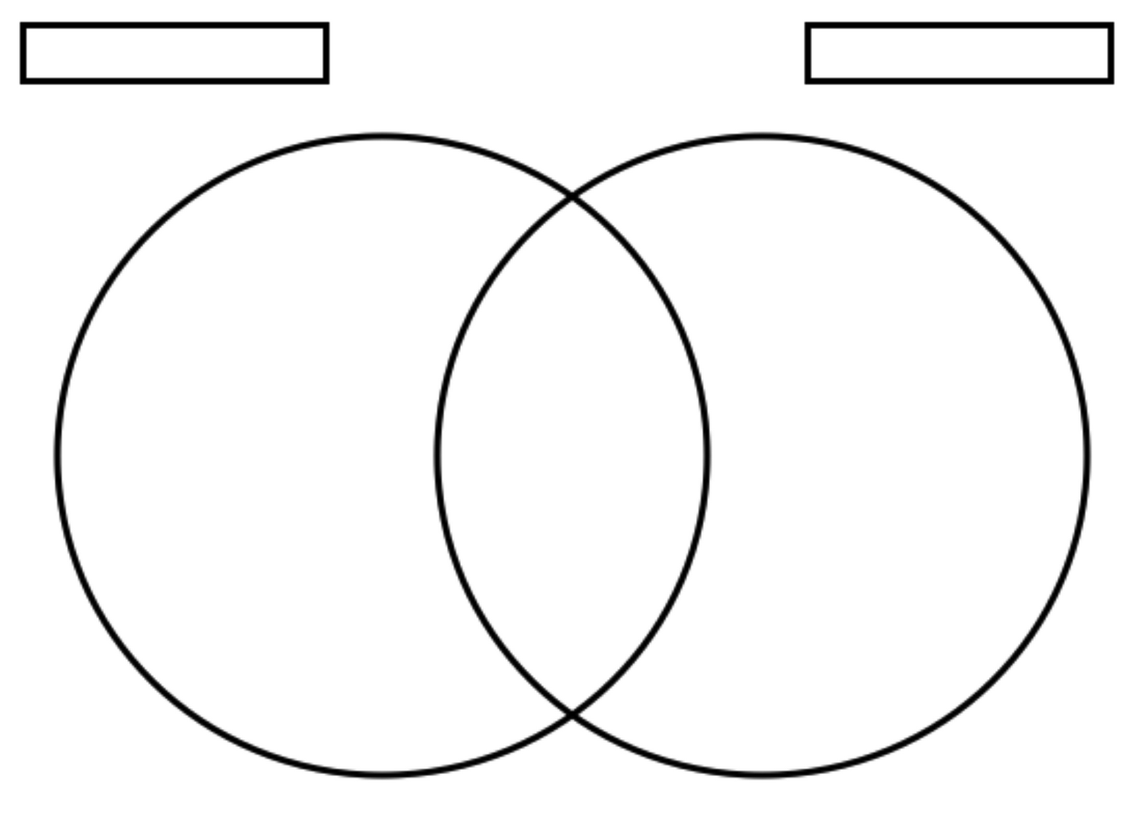

Learning Outcome 2: Be able to plan sports activity sessions
Learning Outcome 3: Be able to deliver sports activity session
Task: Plan and lead a 10-minute sports activity to others within the class.
Planning Sheet
Venue
Number of participants |  |  |  |  | Age range |  |  | Ability level
Equipment
Session Objectives
Activity |  |  |  |  |  | Teaching Points
Immediate response to how the session went

Learning Outcome 4: Be able to evaluate own performance in delivering a sports activity session
Task: Having delivered your session, have a chat with a partner about how both of your sessions went. Were they successful? Did they meet the objectives? What were you happy about? What was not so successful?
Complete the evaluation questions below to help you reflect on your session plan.
Session Plan Evaluation
What went well?
What didn’t go so well and why?
Were the session objectives met?
Did you follow your plan? If no what did you do differently?
What could be improved in the future?

Contemporary Issues in Sport

Within this unit, learners will begin to understand the different issues, which affect participation of different user groups. These user groups include ethnic minorities, retired people/people over 50, families with young children, single parents, children, teenagers, disabled people, unemployed/ economically disadvantaged and working singles or couples.
Learners will appreciate strategies that can be used to engage these groups. Learners will then develop an appreciation about how sport can be used to promote god values, locally, nationally and internationally. This includes looking at the Olympic and Paralympic movements and the values that the Olympic movement aims to promote. Through the appreciation of contemporary issues, learners will begin to understand the promotion of ethical behaviour within sport and the role of various national governing bodies and organisations. This involves looking at the aims of these organisations and how their funding is achieved.

Learning Outcome 1: Understand the issues, which affect participation in sport
Learning Outcome 2: Know about the role of sport in promoting values
Learning Outcome 3: Understand the importance of hosting major sporting events
Learning Outcome 4: Know about the role of national governing bodies in sport

Learning Outcome 1: Understand the issues, which affect participation in sport
Task: List potential barriers to participation in sport
Many groups of people face barriers or factors that may make participation in sport or physical activity particularly difficult. Those facing particular barriers to their participation can be categorised into different user groups. These include:
- Ethnic minorities
- Retired people/ people over 50
- Families with young children
- Single parents
- Children
- Teenagers
- Disabled
- Unemployed/ economically disadvantaged
- Working singles and couples
Choose two of these user groups and list the potential barriers to participation in sport they may face.

1)

2)

Learning Outcome 2: Know about the role of sport in promoting values
Task: Complete the questions below regarding performance-enhancing drugs as to why some athletes choose to break the rules and take them.
Performance Enhancing Drugs
Why take them? | Why not?

What is WADA?

Why do you think some performers knowingly break the rules and hope to get away with prohibited drug use? Do you feel it is worth the risk?

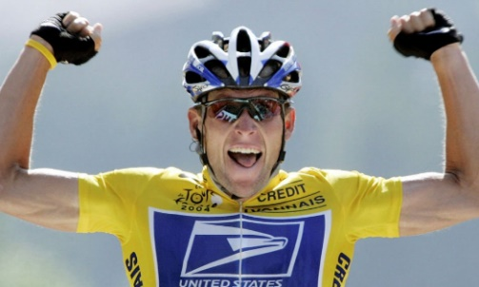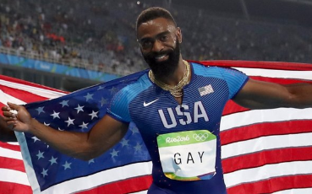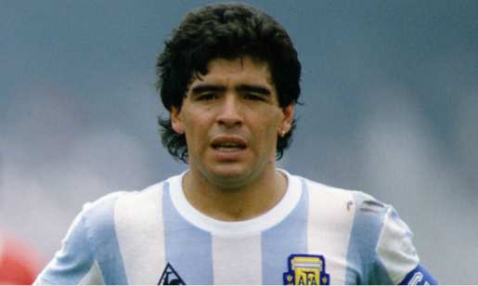
Learning Outcome 3: Understand the importance of hosting major sporting events
Task: Compare the similarities and differences of two of Football’s major sporting events. Complete the Venn diagram for the FA Cup final and the FIFA Football World Cup. Any similarities the two events share should be placed in the middle section of the two circles.

Learning Outcome 4: Know about the role of national governing bodies in sport.
Task: Choose a sport of your choice and research their national governing body (NGB). You will need to find as much information about the NGB and how they work to be able to answer the questions below.
.
National governing bodies (NGBs) are independent bodies that have a responsibility to govern and manage their sport within a country. There is generally an NGB for every sport.

There are many national governing bodies but if you are unsure where to begin or what sport to choose you could try looking at one from the list below.
- The Football Association – www.thefa.com/
- The Rugby Football Union – www.englandrugby.com/
- England Athletics – www.englandathletics.org/
- England Netball – www.englandnetball.co.uk/
- England Hockey – www.englandhockey.co.uk/
- British Gymnastics – www.british-gymnastics.org/

What NGB and sport have you researched?

When was the NGB formed?

How does the NGB benefit the sport?

How does the NGB help the development of players and athletes?

Can you summaries what the NGB is responsible for?

Sport and the Media

Media is defined by the Oxford Dictionary as the ‘main means of mass communication (broadcasting, publishing, and the Internet) regarded collectively’.
The media has four main functions: to inform, educate, entertain and advertise. Sport uses the media to promote itself and, in turn, the media uses sport to promote and maintain people’s interests in its products. In other words, the media uses sport to sell itself.
This unit required learners to look at a range of different media and how they differ in their sports coverage. The unit also looks at the impact the media has on sport and how this has changed over the years. The unit also investigates the effect the media has had on public interest and involvement in sport.
By completing this unit, learners will develop their knowledge and understanding of the relationships between sport and the media, as well as their ability to evaluate and interpret the different ways in which sports events may be represented by the media.
The skills developed would be relevant in a range of careers and roles within the sports industry, such as sports reporting/broadcasting, sports analysis or research and public relations or media work within a sports organisation.

Learning Outcome 1: Know how sport is covered across the media
Learning Outcome 2: Understand positive effects that the media can have on sport
Learning Outcome 3: Understand negative effects that the media can have on sport
Learning Outcome 4: Understand the relationship between sport and the media
Learning Outcome 5: Be able to evaluate media coverage of sport

Learning Outcome 1: Know how sport is covered across the media.
Task: Create mind maps for the four forms of media below and how they are used to present and promote the latest information in the sports industry.

Television

Written Press

Radio

Internet

Learning Outcome 2: Understand positive effects that the media can have on sport
Learning Outcome 3: Understand negative effects that the media can have on sport
Task: You need to consider the statements below and colour in whether you believe the statements are positives or negatives effects the media can have on sport. Use a colour code key to make it clear the difference of positive and negative statements (e.g. Green positive/ Red negative).
Colour Key
Positives effects
Negatives effects
There is an on going increased pressure on officials as the decisions they make are scrutinise throughout and after the game within the media. Meaning that incorrect or poor decisions are often highlighted and debated often questioning the ability of the officials.
Sport has become a vehicle for promoting all sorts of good e.g. shaving products, shoes, banks and cereals.

Many aspects of popular sports have been changed for television and this has resulted at times the loss of traditional sporting values.

Expert opinions and statistics educate listeners, readers and viewers.

People’s knowledge of sports is often limited as it is based on what is in the media.
People are inspired to participate within sport the more they watch, listen and read.
Minority sports have grown due to television airtime, filling the gaps between traditional well-known sports.

With more live sporting event being shown on TV now a days there is less spectators attending due to the ease of being able to watch from the comfort of their homes.
The way, which a performer conducts, they have an effect on the image of the sport and expectations of behaviour by those involved.
Sports receive an increased income, which can be used at grassroots level to make participation easier, or at elite level to support performers at the top of their profession.

Role models are developed within athletes/ players/ coaches within sport. They are portrayed within the media and can be seen to motivate and inspire others.

Such forms of violent conduct such as fighting, pushing, shoving and unsporting behaviour and swearing, is more common and likely to be heard in sport because nowadays there are far more microphones and cameras at sporting events.

The media provides unlimited access to information about a favourite team/ club/ performer.
Inappropriate behaviour of athletes is often happens on the pitch, court or in the stadium but because some performers are high profile often we see and hear about their behaviour outside of the sport.

Learning Outcome 4: Understand the relationship between sport and the media
Task: Watch a sporting event of your choice – list any sponsorships you see when watching the sports event and where you see them e.g. players shirts, adverts, signs around the stadium.
Sponsorship – Where a company pays money to a team or individual in return for advertising their goods.
Sports event:
What sponsorship did you see when watching?

Learning Outcome 5: Be able to evaluate media coverage of sport.
Task: Below are two pictures of the same story but presented within a tabloid and broadsheet. Write around the two articles the differences and the similarities of the broadsheet and tabloid.

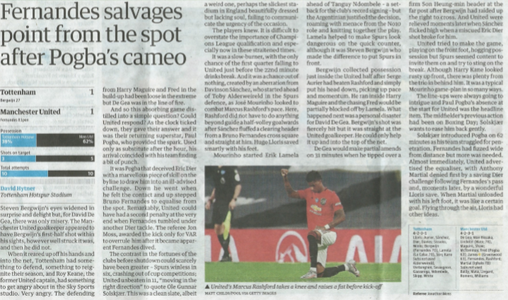
Broadsheet

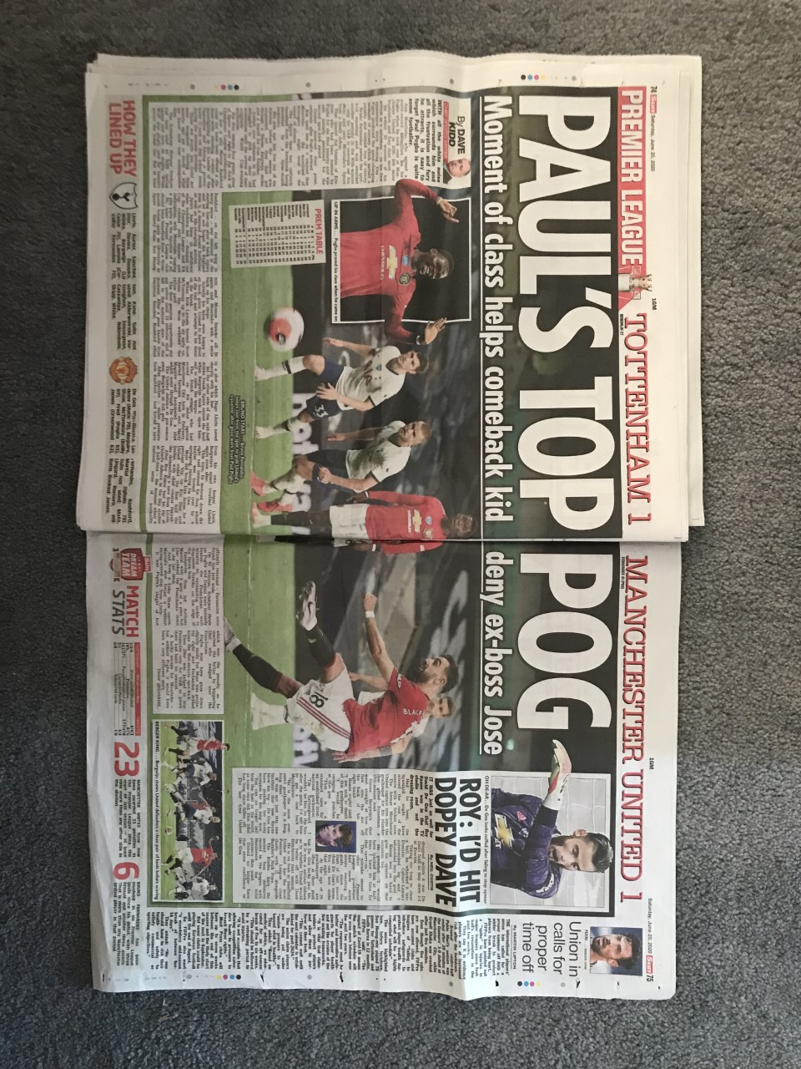

Tabloid

What article is more attractive and stands out to you which you would prefer to read? Why is this?
_______________________________________________________________
_______________________________________________________________
_______________________________________________________________

Developing Sport Skills

There are many other ways of being involved in sports and the sport and leisure industries apart from being an elite performer; for example: physical education teacher, sports officials, roles within national governing bodies, sports facility management, People enter these roles because they developed an interest in sport and physical activity through performing. Participation in sport and physical activity provides young people with a range of transferable skills. They can learn to work both independently and as part of a team; to communicate with teammates or to an audience through performance; to perform under pressure; to use initiative to solve problems and to make decisions, considering rapidly changing conditions around them.

Learning Outcome 1: Be able to use skills, techniques and tactics as an individual performer in a sporting activity
Learning Outcome 2: Be able to use skills, techniques and tactics as a team performer in a sporting activity
Learning Outcome 3: Be able to officiate in a sporting activity
Learning Outcome 4: Be able to apply practice methods to support improvement in a sporting activity

Learning Outcome 1: Be able to use skills, techniques and tactics as an individual performer in a sporting activity.
Task: There is a difference between a skill and technique and tactics and strategies. All four are incredibly important to a sports performance but what is the difference between them? Describe the differences below.
Describe the difference between a skill and technique.
Describe the difference between tactics and strategies.

Learning Outcome 2: Be able to use skills, techniques and tactics as a team performer in a sporting activity.
Task: Choose one of the scenarios below and write down how you would approach the scenario and the tactics you would suggest for the team in this situation.

Scenarios to choose from
Scenario 1: You are representing the SBE football team and are currently drawing 2-2 in the semi-final of the county cup. There is 15 minutes left of the second half. What tactics and approach to the game would you suggest in order to win the game and make it through to the final?

Scenario 2: You are a team member of a local netball team. You are currently playing in a tournament final and you down 9 – 5 with 8 minutes of the game left to play. The opposing team has two very tall defenders who are intercepting all high loopy passes. What approach and tactics would you suggest playing?
Your scenario response

Learning Outcome 3: Be able to officiate in a sporting activity
Task: Within your lesson you should have looked at either basketball, netball or football. Depending on the sport you covered in your lesson can you remember the officials hand signals and meanings? Fill in the boxes below the pictures with the name of the correct hand signals.
Basketball Official Hand Signals -
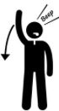
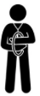
Travelling Pushing Time out 3 second violation
Blocking Cancel score Player foul Start the clock
Stop clock 1 point 2 points 3 points

Football Official Hand Signals –
Elbowing Penalty Kick Hand ball Corner Kick Disallowed Goal
Goal Time-out Pushing Yellow Card Red Card
Offside Offside Location Direct Free Kick Indirect Free Kick Advantage/Play on

 |  |  | 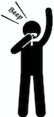 | 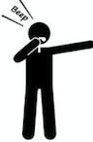

Netball Official Hand Signals -
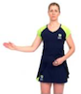 | 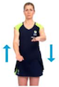 |  | 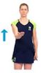 | 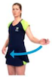
 | 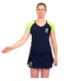

Direction of pass Over a third Footwork Advantage
Throw in/ goal line Goal scored Hold time Toss up

Learning Outcome 4: Be able to apply practice methods to support improvement in a sporting activity
Task: Complete the table below considering the strengths and weakness for both a team performer and an individual performer. When providing weakness you need to be able to suggest how to improve this aspect and ways in which this could be done.
Individual Performer | Team Performer
Strength | Strength
Strength | Strength
Weakness | Weakness
How to improve | How to improve
Weakness | Weakness
How to improve | How to improve

Evaluation
You now need to rank order the units you have covered. Give 1 to the unit you enjoyed the most/found the most interesting and 8 to the unit you enjoyed the least/found the least interesting.
Unit | Ranking
Applying Principles of Training
Contemporary Issues in Sport
Developing Sports Skills
Reducing the Risk of Sports Injuries
Sport and the Media
Sports Leadership
Sports Psychology
Technology in Sport

You will have a 1-1 conversation with your teacher about which course you are going to continue to study, either the Sport Studies or the Sport Science. Factors that will be considered in making this decision could be engagement levels, future aspirations, as well as other aspects.

