Example case study – Raymond Loewy
Raymond Loewy 1893–1986
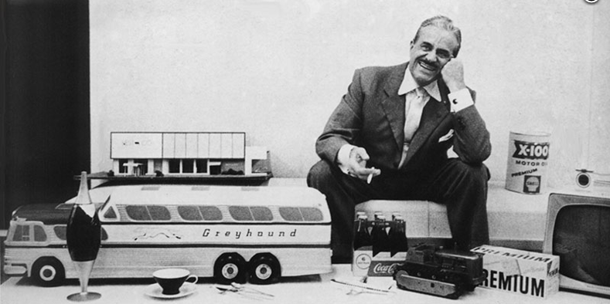

Hailed as the Father of Industrial Design, Raymond Loewy’s influence has touched everyone in the modern world and gave the American way of life a distinct identity which has travelled across the globe. He said of himself “… I have made the mundane side of the 20th century more beautiful”.
Loewy was born in Paris to Austrian-French parents and distinguished himself at the age of 17 by designing the winning model aeroplane in the Gordon Bennett Cup, which then went on to commercial success in the following year.
After World War I, he moved to New York and worked as window designer for various large department stores as well as working as a fashion illustrator for Vogue and Harper’s Bazaar. His first industrial design commission was in in 1929 to redesign the appearance of the Gestetner duplicating machine, a design that persisted for the next 40 years. This was the first instance of the streamlined look that characterised Loewy’s work which went on to include the Greyhound bus, the Coca-Cola bottle, and the GG1 and S1 locomotives.
In the 1930’s, his successful styling of the Hupp Aerodynamic motor car paved the way for automotive design to become a legitimate profession. Motor manufacturers began to use external stylists like Loewy, who then designed the classic 1953 Studebaker Starliner.
He was quick to realise that a product’s appearance was a saleable commodity and his streamlined look became the emblem of western society. He also understood that appearance had a knock-on effect on production cost and performance, and enhanced the product’s standing in the marketplace: stating that of two similarly specified products, the most aesthetically pleasing would be the most successful.
In addition to his automotive designs Loewy was also a prolific commercial artist and illustrator with simple but effective graphic designs. Of the many logos he created, he said, “We want anyone who has seen the logotype even fleetingly to never forget it.”
Loewy’s ideal of creating beauty through function and simplicity is still in tune with the requirements of industrial production today and his work still influences designer and consumer decisions.

