Shenley Brook End School. Food preparation and nutrition.

|  |
| --- |
| Name ……………………………………………………………………………………………………. |

[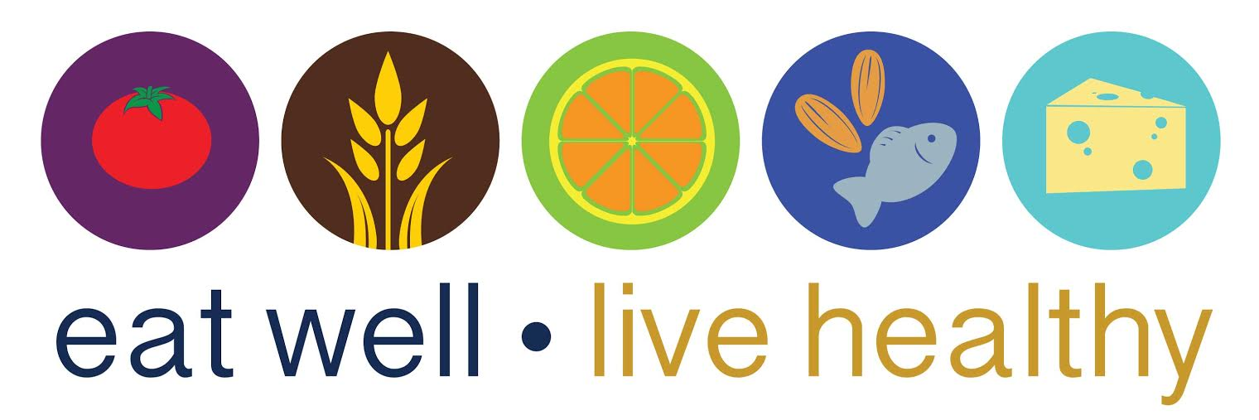](http://www.google.co.uk/url?sa=i&rct=j&q=&esrc=s&source=images&cd=&cad=rja&uact=8&ved=0ahUKEwiE1MCf_LDJAhVCPRoKHc9BBIcQjRwIBw&url=http://www.indoindians.com/tips-on-eating-well/&psig=AFQjCNHH1wKcuDOGw4rvwxTwXr6WeDKIoQ&ust=1448726316739978)

|  |  |
| --- | --- |
| **Year 8** | **Eat well project** |

**Video Questions**

**Answer the following questions about the video that you have just seen.**

1. Why is the waitress a hazard?
2. During food preparation and service, when should you wash your hands?
3. What did the chef wipe the plates with? What should he have used?
4. Name the utensil that the chef used to turn the meat with?
5. Why should you separate raw food from cooked food?
6. Name two vegetables that you saw?
7. During the video, what did the pink highlights indicate?
8. Why do you need to use a clean spoon each time you taste food?
9. What did the little girl have to eat?
10. Name the ‘4C’s

**Storing food safely**

What is cross contamination? ..................................................................................................................................................................................................................................................................................................................................................................................................................................................................

How can we prevent cross contamination in the kitchen?

..................................................................................................................................................................................................................................................................................................................................................................................................................................................................

Complete the table below. Use the correct colours to show what colour the chopping boards should be for each type of food.

Use the thermometer below to show the key temperatures in Food preparation.

(ALL DEGREES CENTIGRADE) **Add the correct information next to the correct temperature**:

Boiling point, freezer temperature, freezing point, fridge temperature, cooked meat temperature and the danger zone.

|  |  |
| --- | --- |
| Bread & Dairy |  |
| Raw  Meat |  |
| Cooked Meat |  |
| Raw  Fish |  |
| Vegetables |  |
| Fruit |  |

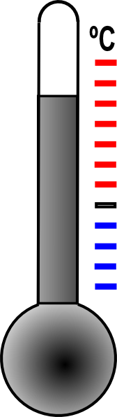

100

75

63

37

5

0

-18

Which 5 groups of people are most at risk of food poisoning? Why?

........................................................................................................................................................................................................................................................................................................................................................................

Food can be contaminated with chemicals, bacteria or physical items. Give an example of each. .........................................................................................................................................................................................................................................................................................................................................................................................................................................................................................................................

**Eat well**

To maintain a healthy diet you need to eat a variety of different foods, plenty of vegetables and fruit, and avoid foods which are high in fats and sugars. These are the UK’s government’s guidelines for a healthy diet:

* Base your meals on starchy foods
* Eat lots of fruit and vegetables
* Eat more fish – including a portion of oily fish each week
* Cut down on saturated fat and sugar
* Try to eat less salt – no more than 6g a day for adults
* Get active and try to be a healthy weight
* Drink plenty of water
* Don’t skip breakfast

The Food Standards Agency uses the ‘eat well guide’ to show the different types of foods and their proportions that people need in order to maintain a healthy and well balanced diet. It is based on the five food groups:

1. Bread, rice, potatoes pasta and other starchy foods
2. Fruit and vegetables
3. Milk and dairy foods
4. Meat, fish, eggs beans and other non-dairy sources of protein
5. Using fats and oils

**Question 1**

On the chart below, label the sections of the eat well guide. Add the colours of each section.

**Question 2**

Name five foods that can be found in the 4 main categories;

The eat well guide is appropriate advice for most people including people of all ethnic origins and people who are of a healthy weight or overweight. It is also suitable for vegetarians.

However, it does not apply to children under 2 years of age because they have different needs. Between the ages of 2 and 5, children should gradually move to eating the same foods as the rest of the family, in the proportions shown on the eatwell plate.

People under medical supervision or with special dietary needs might need to check with their GP, or a registered dietician, to be clear about whether or not the eatwell plate is suitable for them.

**Question 3**

**How does it work?**

As you can see on the eatwell guide, the food we eat has been divided up into different food groups. Try to choose a variety of different food from each of the food groups. This will help you get the wide range of nutrients your body needs to stay healthy and work properly. Many of the things we eat, such as pizzas, casseroles, pasta dishes and sandwiches, are a combination of the food groups. For these sorts of food, you just need to work out the main ingredients and think about how these fit with the sections on the plate. For example, if you’re having a chicken stir-fry with rice, this is made up of: chicken – this fits in the section for meat, fish, eggs, beans and other non-dairy sources of protein. Vegetables – this fits in the section for fruit and vegetables. Rice – this fits in the section for bread, rice, potatoes, pasta and other starchy foods

**Below is a list of all the foods a 12 year old boy ate yesterday.**

|  |  |  |  |
| --- | --- | --- | --- |
| **Breakfast** | **Lunch** | **Dinner** | **Snacks** |
| Chocolate cereal with milk | Cheese sandwich with white bread and butter  Coke  Blueberry muffin | Beef burger and chips  Apple turnover | Three bags of crisps  Chocolate bar  Hot chocolate drink made with whole cream milk  Two cans of fizzy orange |

**Explain why this is not a healthy combination of foods and drinks:**

**________________________________________________________________________________________________________________________________________________________________________________________________________________________________________________________________________________________________________________________________________________________________________________________________________________________________________________________________________**

**Write down all the changes you could make so that it is healthier. For example, drink water instead of fizzy drinks.**

**____________________________________________________________________________________________________________________________________________________________________________________________________________________________________________________________________________________________________________________________________________________________________________________________**

**____________________________________________________________________________**

**Question 4**

**Match the reason to the rule**

A better balanced diet can have benefits for your health and how you look and feel.

Using a different colour for each question, match the reason to the rule

|  |  |
| --- | --- |
| **A Balanced Diet Can Include** | **Benefits** |
| **Low salt intake** | **Good for bone growth** |
| **Plenty of water** | **Less risk of being overweight and less risk of heart disease** |
| **Limited sugary foods** | **Longer lasting energy** |
| **Plenty of fruit and vegetables, at least 5 portions a day** | **Healthier blood pressure** |
| **Milk, cheese and yoghurts** | **Less chance of developing diabetes and tooth decay** |
| **Limited deep fried and fatty foods** | **Healthy skin and hair** |
| **Bread, pasta, rice potatoes ( starchy carbohydrates)** | **Better concentration** |
| **Meat, fish and protein alternatives** | **Helps to grow and repair tissues and muscle** |



**C:\Users\Mann\AppData\Local\Microsoft\Windows\Temporary Internet Files\Content.IE5\Y80V51B5\MC900197880[1].wmfQuestion 5**

**All about Poultry**

Poultry is the name given to chicken, turkey, duck and other birds.

* 95 per cent of chicken are reared (kept) indoors and a standard chicken is about 40 days old when it is slaughtered
* Free range chickens are allowed outside and are reared (kept) in large sheds; they are 56 days old when they are slaughtered
* Organic chickens are allowed to roam the fields and are given organic food to eat. They are 80 days old when they are slaughtered

**Which type of chicken is the most expensive to buy?**

Explain 3 reasons for your choice:

1……………………………………………………..............................................................................................

2………………………………………………………..………………………………………………………….............................

3………………………………………………………................................................................................... …….

**Is chicken good for you?**

Chicken is lower in fat and higher in protein than red meat[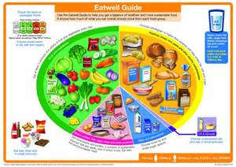](http://www.bing.com/images/search?q=eatwell+guide+2016&view=detailv2&adlt=strict&id=FB124C19E2538E479CF70B79779F720F2907D101&selectedIndex=1&ccid=9CYJE4Pd&simid=608008263078382327&thid=OIP.Mf426091383dd09bb02bbd87287a4d6c7o0)

**Circle which food group chicken belongs to on the eat well guide above.**

**What vitamins does chicken provide us with?** (read the information to help you)

Explain:..........................................................................................................................................

**How can we lower the fat content of cooked chicken?**

Explain:……………………………………………………………………………………………………………………………………

**Question 6**

**VEGETARIANISM**

Types of vegetarian diets

|  |  |
| --- | --- |
| **Term** | **Description** |
| **Lacto-ovo-vegetarian** | Don’t eat meat, fish and poultry; but will eat dairy products and eggs (usually free range). |
| **Vegan** | Don’t eat any foods of animal origin (will not eat dairy products either); diets comprise vegetables, vegetable oils, cereals, pulses such as beans and lentils, nuts, fruit and seeds |

Why do people choose a vegetarian diet?

State five reasons, why people choose to follow a vegetarian diet.

1.

2.

3.

4.

5.

**Meat Analogues (Alternative Proteins)**

Some people choose not to eat meat for a variety of reasons and obtain all their protein from other sources. In recent years manufacturers have produced many meat-like products, called ‘meat analogues’, which mimic the sensory properties of meat and can be used to replace or extend meat in traditional products, e.g. textured vegetable protein (TVP) and myco-protein.

Question 7

Using this chart to help you, plan a day’s menu for a vegetarian.

Animal and plant sources of vitamins and minerals.

|  |  |  |  |
| --- | --- | --- | --- |
| **Nutrient** | **Function** | **Animal Sources** | **Plant Sources** |
| **Protein** | For growth and development | Meat, poultry, fish, eggs, milk, cheese, yogurt | Soya protein, pulses, bread, grains, seeds, potatoes |
| **Calcium** | Healthy teeth and bones | Milk, cheese, yogurt, tinned sardines, and salmon including the soft bones if eaten. | Fortified soya milk, tofu, seeds, (e.g. sesame seeds), green leafy vegetables (e.g. spring greens), nuts (e.g. almonds), bread (especially white bread), dried fruit (e.g. apricots) |
| **Iron** | Helps make red blood cells | Liver, red meat, chicken, fish, eggs (non-haem iron) | Fortified breakfast cereals (the label should be checked to see if iron has been added), bread, pulses (e.g. soya beans), green vegetables, dried fruits (e.g. apricots), nuts, plain chocolate |
| **Vitamin A** | For vision in dim light, for healthy skin and growth. | Liver, butter, whole milk, cheese | Yellow/orange vegetables* (e.g. carrots) and dark leafy ones (e.g. parsley, watercress), yellow/orange fruit (e.g. mangoes, and apricots - fresh or dried), fortified margarine, sweet potato |
| **Vitamin B12** | Help maintain healthy blood and nerve functions. | Liver, meat, poultry, fish, milk and milk products, eggs | Yeast extract (Marmite) Fortified products (e.g. soya milk), some margarines, textured vegetable protein products, and some infant foods |
| **Vitamin D** | Helps the absorption of calcium. | Oily fish, whole milk and its products, eggs | Fortified margarine, fortified breakfast cereals (the label should be checked to see if vitamin D has been added) |

|  |  |  |  |
| --- | --- | --- | --- |
| **Breakfast** | **Lunch** | **Dinner** | **Snacks** |
|  |  |  |  |