Homework 1: Sources, origins and properties

All fabrics are derived from either animal, chemical or vegetable sources.

State which category of source silk is derived from. [1]

Explain how silk yarn would be processed into fabric. [3]

Some products carry the information label shown below.
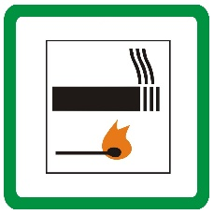
- Briefly explain what the label means when attached to a product. [1]

Suggest one product that is likely to carry this label. [1]

Consumer demand for sustainable products is on the rise.
Describe the ways in which the production and use of a garment could be more sustainable.
Use examples to illustrate your points. [6]

[Total: 12 Marks]

