Worksheet 1: Sources, origins and properties
Task 1
Fill in the grid following the instructions below:
Fibres and fabrics

Now, match the fibre or fabric to the correct raw materials.

- Nylon
- Wool
- Cotton
- Hemp
- Polyester
- Linen
- Angora
- Lycra
- Kevlar
- Silk
- Acrylic
- Bamboo
- Cashmere
- Nomex
Raw material sources

Match these raw material sources into the correct categories.

- Silkworm
- Petrol-based chemicals
- Goat
- Cotton plant
- Sheep
- Hemp plant
- Flax
- Aramids
- Rabbit
- Bamboo plant

Animal |  | Chemical |  | Vegetable
Raw Material Source | Fibre or fabric | Raw Material Source | Fibre or fabric | Raw Material Source | Fibre or fabric

Task 2
Match the following terms and images to their definitions:
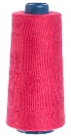 | Yarn |  | Long, smooth strands, usually from synthetic sources
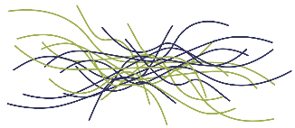 | Staple fibres |  | A thread produced from spinning fibres together which are then knitted or woven into fabrics
 | Filaments |  | Short, hairy fibres usually from natural sources

Task 3
Dissect your fabric swatch into the warp and weft and then disassemble the yarn into fibres. Document this process in the boxes below using labelled diagrams.
Yarn
Draw a diagram to show the structure the yarn – is it a staple yarn or filament yarn?

Fibre
Draw a diagram to show the fibres that make up the yarn – are they staple or filament fibres?

Fabric
Draw a diagram to show structure of the fabric – is it woven or knitted, plain weave or twill weave?

Task 4
Study the lifecycle of a traditional t-shirt below:
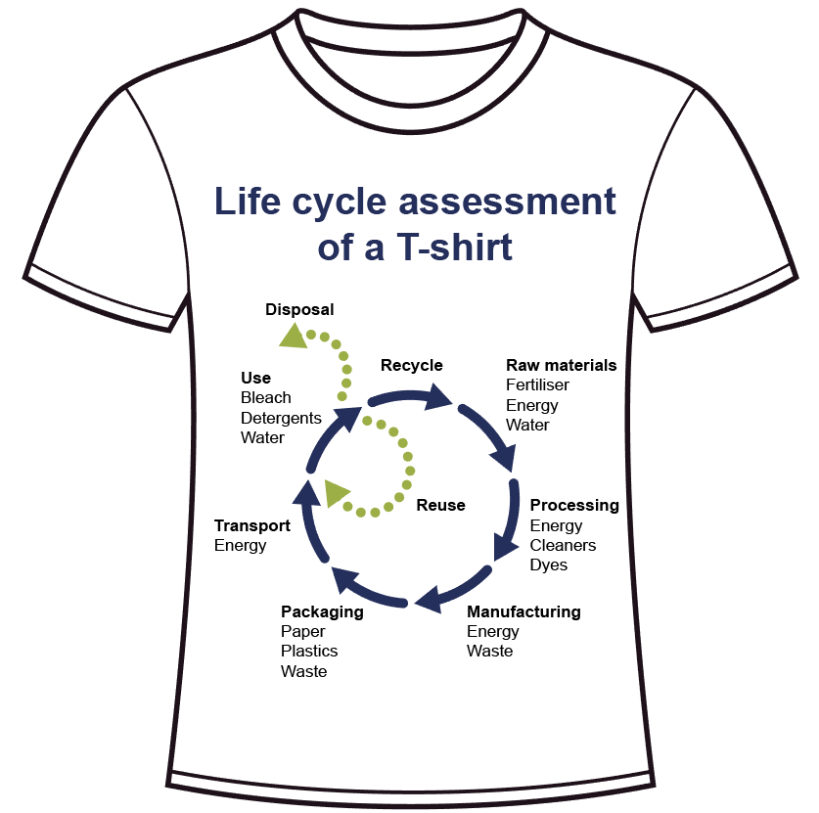
In pairs, use the diagram above to list all the ways you could reduce the environmental impact along the lifecycle of a t-shirt or similar garment. Use the 6Rs to help you:

Reduce Reuse Recycle Rethink Repair Refuse

Sourcing:

Manufacture:

Distribution:

Use:

Recovery:

