Worksheet 3: Manufacture and finishing
Task 1 – Surface treatments and finishes
Match the definitions to the correct finish or treatment then specify a practical application for each treatment and justify your answer.
Description |  | Treatment  or finish | Application
Specialist paper is used to fuse an inkjet printed image on to fabric |  | 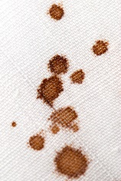  Stain Protection | Suggestions for use:  Rugs and carpets
Justification of use:
These products are prone to spills and cannot be washed easily
Treatment to form a moisture repelling seal |  | 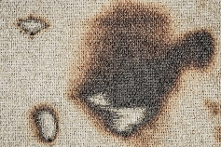  Flame Retardants | Suggestions for use:
 |  |  | Justification of use:
Coating which forms a protective barrier to prevent substances from being absorbed into fibres |  | Heat Transfer Print | Suggestions for use:
 |  |  | Justification of use:
Use of abrasive rollers to lift fibres and form a nap on the fabric to make it warmer and softer to the touch |  | 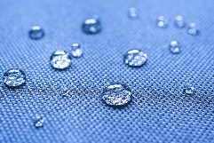  Waterproofing | Suggestions for use:
 |  |  | Justification of use:
Use of a series of rollers to press, iron, emboss or deboss rolls of fabrics |  | 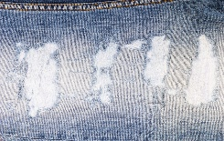  Distressing | Suggestions for use:
 |  |  | Justification of use:
Treatment to prevent or slow combustion |  | 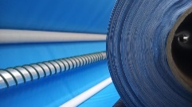  Calendaring | Suggestions for use:
 |  |  | Justification of use:
A light resin applied to make ironing and drying faster |  | 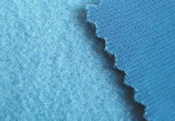  Brushing | Suggestions for use:
 |  |  | Justification of use:
Chemical or mechanical deterioration of the colour or texture of fibres and fabrics |  | 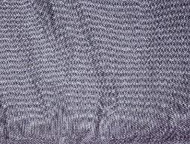  Crease Resistance | Suggestions for use:
 |  |  | Justification of use:

Task 2 – Dyeing fabric
List some of the advantages and disadvantages of dyeing fabric in batches versus dyeing continuously.
Batch Dyeing | Continuous Dyeing

Task 3 – Screen printing
Study the screen prints below.
How many screens would be required for each print?
Number of screens needed: | Number of screens needed:

Explain the limitations of screen printing?

Task 4 – Quality control
Compare the differences between the original sample and Sample 2. Circle any defects.
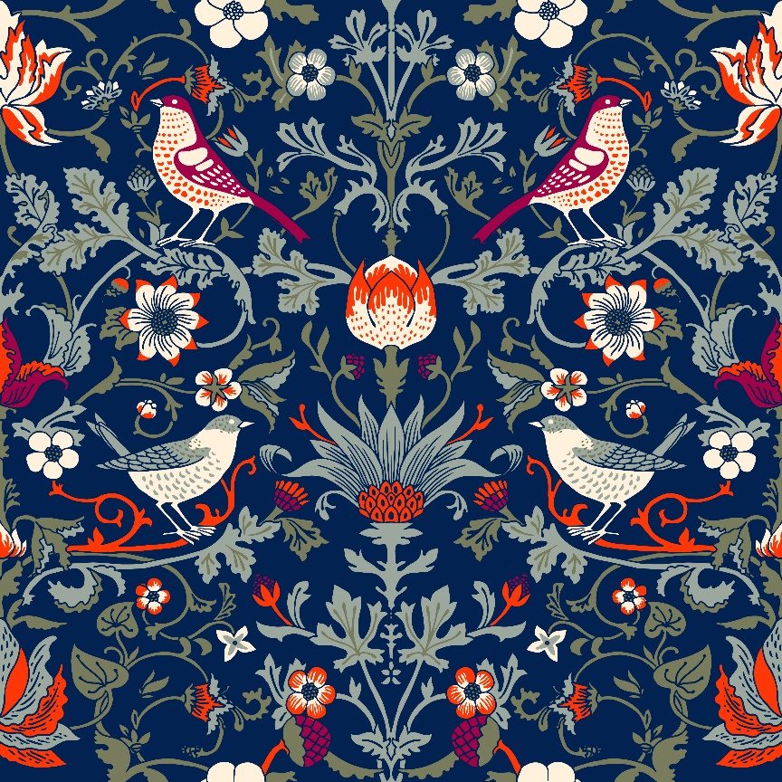
Original sample
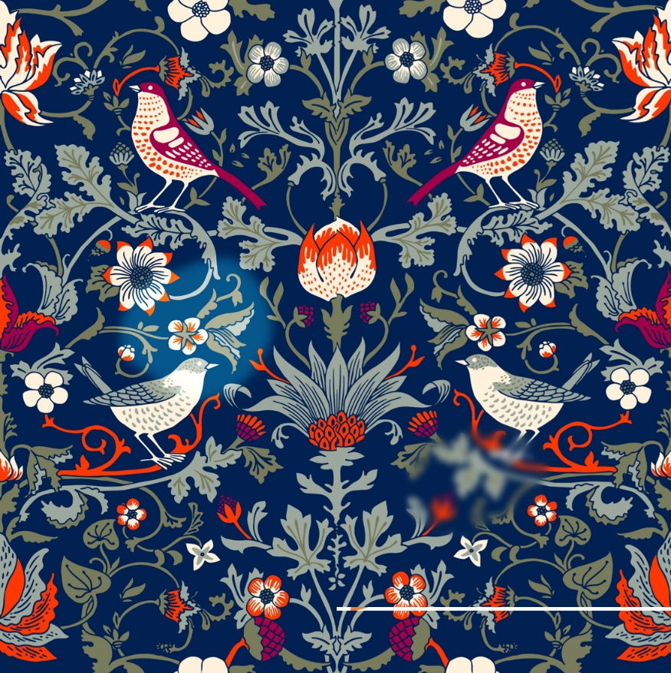
Sample 2

Task 5 – Product design
The curtains below are to be manufactured in a batch of 2500 units. Name and explain suitable manufacturing techniques considering the following:
  - Dyeing
    - Dyed as fibre, yarn, fabric or finished product?
    - How was it dyed – batch or continuous?
  - Method of printing
  - Quality control check for pattern
  - Surface treatment

Make detailed notes and add annotations to the images below:
