Worksheet 2: Working with textiles
Task 1
- Study the image below and label any textile components you think have been used.

- The properties of different materials influence their use and affect performance.
(a) (i) Suggest one material that would be suitable for use in the manufacture of the rider’s shirt.

(ii) Give one property of this material that makes it suitable for jockeys.

(iii) Explain how this material property affects the performance of the rider.

(b) State the primary source material used to manufacture the fabric stated in part (a).

Task 2
Match the cutting tools to the correct name and job. Use the name bank below to help you.
Electric Rotary Cutter | Tailor’s shears
Embroidery scissors | Textiles Bandsaw
Pinking Shears | Unpicker / Seam Ripper
Rotary Cutting Wheel

Image | Tool name |  | Description
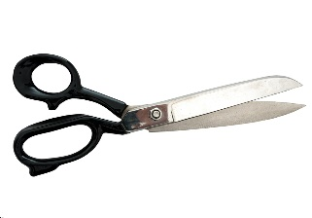 | Tailor Shears / Shears |  | Circular blade can cut several layers of fabric at a time.
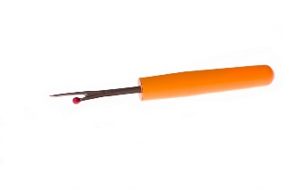 | Unpicker / Seam Ripper |  | Industrial tool used to cut tens of layers of fabric at a time, often used with a chainmail glove.
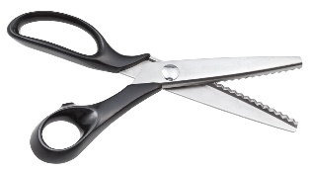 | Pinking Shears |  | Common cutting tool used for all general textiles work. Must not be used on paper as they will become blunt.
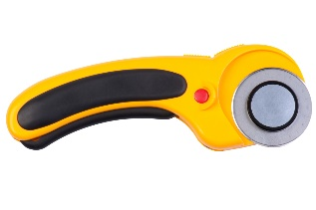 | Rotary Cutting Wheel |  | Used to remove unwanted stitching.
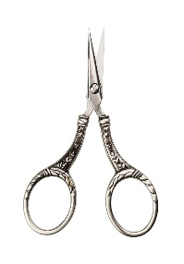 | Embroidery Scissors |  | Used to create a zig-zag cut at the edge of a fabric to add decoration or stop fabric from fraying.
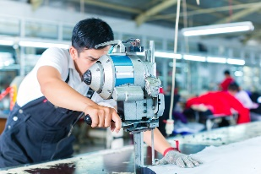 | Textiles Bandsaw |  | Industrial tool with a circular blade for cutting several layers of fabric in one pass.
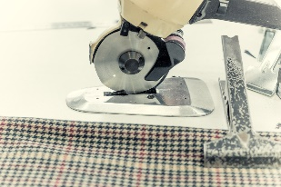 | Electric Rotary Cutting Wheel |  | Small tool used for very accurate work such as beading or embroidery.

Task 3
Use the space below to sketch a hiking jacket.
- First brainstorm the different processes and components you might need - aim to incorporate as many as you can
- Add annotations to name and justify the processes and components you have used e.g. I added gathers for added comfort and ease of use… Dye was used to enhance the surface aesthetic.
