Year 8: ASK Yourself!
DRAMA - Autumn Term: Advanced Skills & Genre
S
 | Launching | Developing | Progressing | Mastering
 | SKILLS
PRACTICAL | I can,  WITH HELP... | I can  REGULARLY... | I can SUCCESSFULLY & OFTEN…. | I can  SKILFULLY & ALWAYS
 | - Work as part of a team.  - Perform in role plays that include advanced skills such as Slow-Motion, Synchronisation, Mirroring & Marking the Moment.  - Create realistic characters that have some difference to myself through naturalism.  - Use narration, exaggerated characterisation and storytelling in Pantomime.  - Show some understanding of Horror and how to create atmosphere. | - Work as part of a team and support ideas.  - Perform in role plays that include advanced skills such as Slow-Motion, Synchronisation, Mirroring & Marking the Moment.  - Demonstrate performance understanding of the genres Horror, Pantomime & Naturalism.  - Create believable, realistic characters through naturalism.  - Use my vocal skills to narrate and create exaggerated characterisation and storytelling in Pantomime.  - Use storytelling, lighting, and sound to create atmosphere in horror performances. | - Work as part of a team and support ideas.  - Perform in role plays that include advanced skills such as Slow-Motion, Synchronisation, Mirroring & Marking the Moment.  - Demonstrate and can perform different genres of theatre, Abstract, Horror, Pantomime & Naturalism.  - Create believable, realistic characters through naturalism.  - As a performer and a director, I can use narration, exaggerated characterisation and storytelling in Pantomime.  - As a performer and a director, I can use physical theatre, soundscapes & symbols to create abstract performance.  - As a performer and a director, I can use vocal skills through storytelling, lighting and sound to create atmosphere in horror performances.  - Demonstrating an understanding of Immersive theatre | - Work as part of a team and support ideas.  - Perform in role plays that include advanced skills such as Slow-Motion, Synchronisation, Mirroring & Marking the Moment.  - Demonstrate and perform different genres of theatre, Abstract, Horror, Pantomime & Naturalism.  - Create believable, realistic characters through naturalism.  - As a performer and a director, I can use narration, exaggerated characterisation and storytelling in Pantomime.  - As a performer and a director, I can use physical theatre, soundscapes & symbols to create abstract performance  - As a performer, designer, and a director I can use vocal skills through storytelling, lighting and sound to create atmosphere in horror performances.  - Creatively directing and performing the elements of Immersive theatre which shows an understanding of the audience experience.
Autumn Term 1: Advanced Skills & Genre

 | Launching | Developing | Progressing | Mastering
K | KNOWLEDGE
VERBALLY & WRITTEN | I can, WITH HELP offer knowledge of… | I can REGULARLY offer knowledge of…. | I can SUCCESSFULLY & OFTEN offer knowledge of… | I can SKILFULLY & ALWAYS give knowledge of…
 | - The definitions of key Drama Skills & Genres  - How to use these elements in my rehearsal and performances.  - Feedback and my discussion is with my teacher.  - Offering feedback on things I liked. | - Key Drama Skills & Genres and can suggest how to use them in my rehearsals and performances.  - Feedback and my discussion is to my teacher and peers in a group.  - Offering feedback on things I liked and why. | - Key Drama Skills & Genres and can define them using technical vocab.  - Key Drama Skills & Genres and can direct creatively to stimuli using these skills.  - Feedback and my discussion is to the class.  - Offering constructive feedback and why I felt this. | - Key Drama Skills & Genres and can use them within evaluation during class discussions & written tasks. vocab.  - Key Drama Skills & Genres and can direct creatively to stimuli using these skills.  - Feedback and my discussion is to my teacher and class.  - Offering constructive feedback and I can make suggestions to help improve work.

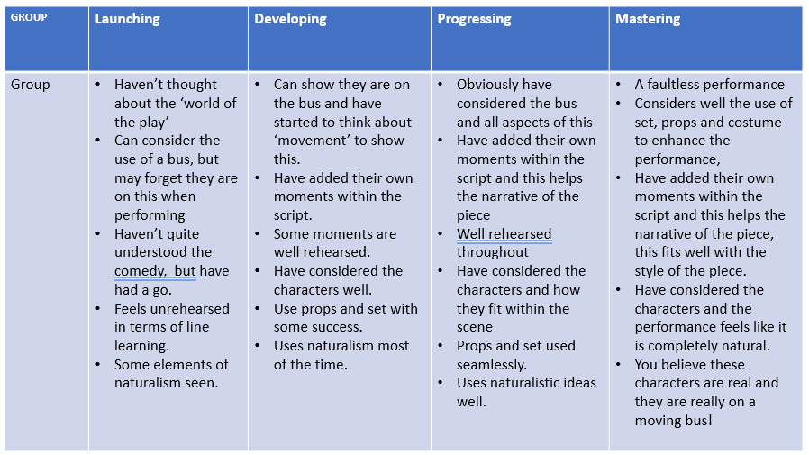
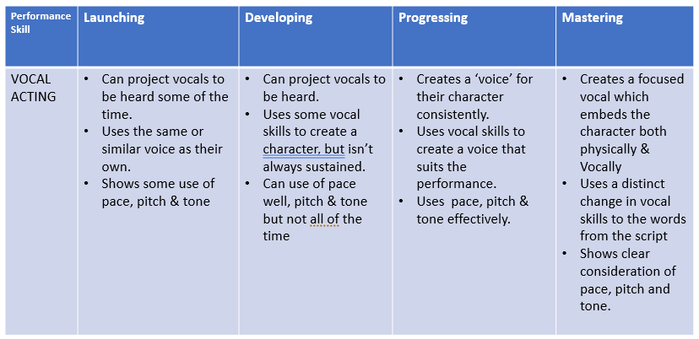
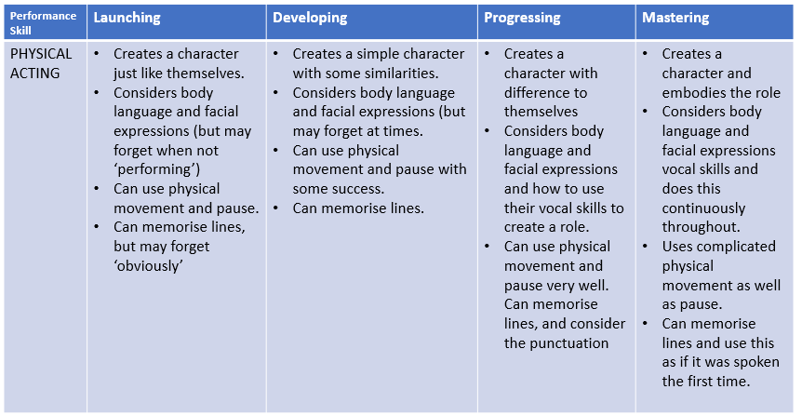
Pre-Assessment - Naturalism- Our Day Out

