Year 8: ASK Yourself!
DRAMA - Summer Term: Film Trailers
S
 | Launching | Developing | Progressing | Mastering
 | SKILLS
PRACTICAL | I can,  WITH HELP... | I can  REGULARLY... | I can SUCCESSFULLY & OFTEN…. | I can  SKILFULLY & ALWAYS
 | - Work as part of a team.  - Perform in role- plays that recall prior knowledge of skills & genre.  Demonstrate performance understanding of film genres such as Horror, Sci-fi, Comedy & Naturalism.  - Create realistic characters that have some difference to myself.  - Use my own voice to narrate voice overs in performance.  - Perform some the elements of film trailers. | - Work as part of a team and support ideas.  - Perform in role-plays that recall prior knowledge of skills & genre.  - Demonstrate performance understanding of film genres such as Horror, Sci-fi, Comedy & Naturalism.  - Create believable, realistic characters.  - Use my vocal skills to narrate voice overs in performance.  - As a performer I can use knowledge of film genres, camera angles and structure.  - Creatively perform the elements of film trailers. | - Work as part of a team and support ideas.  - Perform in role-plays that recall prior knowledge of skills & genre.  - Demonstrate and perform different genres of film such as Horror, Sci-fi, Comedy & Naturalism  - Create believable, realistic characters through a range of genre/styles.  - As a performer and a director, I can use knowledge of film genres, camera angles and structure.  - Use my vocal skills confidently to narrate voice overs in performance.  - As a performer and a director, I can use vocal skills through storytelling, lighting and sound to create the correct atmosphere for a film genre.  - Creatively direct and perform the elements of film trailers. | - Work as part of a team and support ideas.  - Perform in role-plays that recall prior knowledge of skills & genre.  - Demonstrate and perform different genres of film such as Horror, Sci-fi, Comedy & Naturalism  - Create believable, realistic characters through a range of genre/styles  - As a performer and a director, I can confidently demonstrate knowledge of film genres, camera angles and structure.  - Use my vocal skills effectively to narrate voice overs in performance.  - As a performer and a director, I can use physical theatre, soundscapes & symbols to create abstract performance  - As a performer and a director, I can use vocal skills through storytelling, lighting and sound to create the correct atmosphere for a film genre.  - Creatively & effectively direct and perform the elements of film trailers.
Autumn Term 1: Advanced Skills & Genre

 | Launching | Developing | Progressing | Mastering
K | KNOWLEDGE
VERBALLY & WRITTEN | I can, WITH HELP offer knowledge of… | I can REGULARLY offer knowledge of…. | I can SUCCESSFULLY & OFTEN offer knowledge of… | I can SKILFULLY & ALWAYS give knowledge of…
 | - The definitions of key drama skills & film genres  - How to use these elements in my rehearsal and performances.  - Feedback and my discussion is with my teacher.  - Offering feedback on things I liked. | - The definitions of key drama skills & film genres and can suggest how to use them in my rehearsals and performances.  - Feedback and my discussion is to my teacher and peers in a group.  - Offering feedback on things I liked and why. | - The definitions of key drama skills & film genres and can define them using technical vocab.  - Key drama skills & film genres and can direct creatively to stimuli using these skills.  - Feedback and my discussion is to the class.  - Offering constructive feedback and why I felt this. | - The definitions of key drama skills & film genres and can use them within evaluation during class discussions & written tasks. vocab.  - Key drama skills & film genres and can direct creatively to stimuli using these skills.  - Feedback and my discussion is to my teacher and class.  - Offering constructive feedback and I can make suggestions to help improve work.

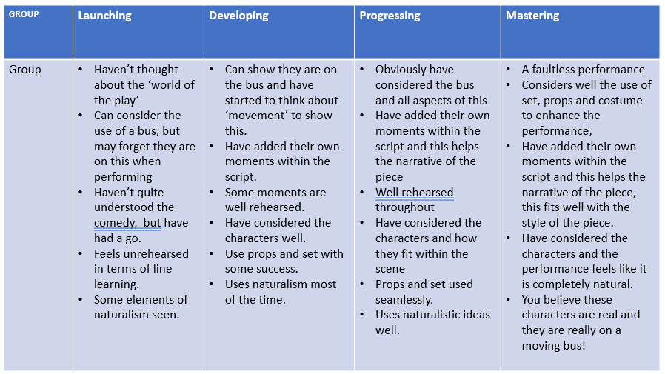
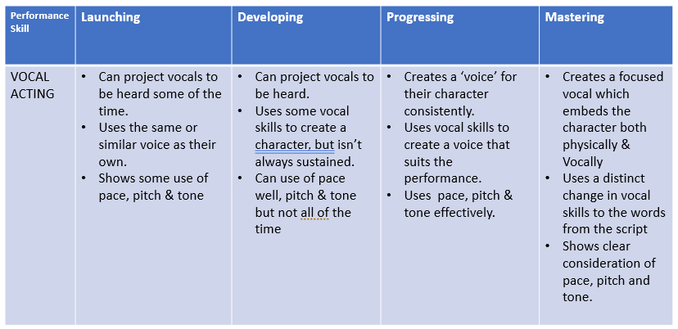
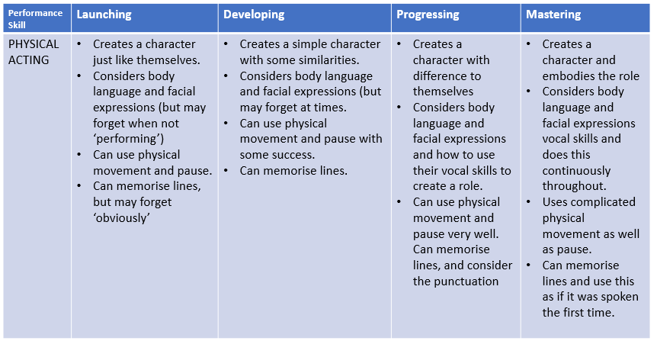
Pre-Assessment - Naturalism- Our Day Out

