Year 8: ASK Yourself!
DRAMA – Spring Term: Macbeth
S
 | Launching | Developing | Progressing | Mastering
 | SKILLS
PRACTICAL | I can,  WITH HELP... | I can  REGULARLY... | I can SUCCESSFULLY & OFTEN…. | I can  SKILFULLY & ALWAYS
 | - Work as part of a team.  - Explore characters of Shakespeare’s Macbeth and give a little insight into them.  - In character creation I create roles that are similar to myself.  - Create realistic characters that have some difference to myself through naturalism.  - Use prior knowledge of Genre & Skills to perform in role plays that include advanced skills such as Slow-Motion, Synchronisation, Mirroring & Marking the Moment.  - Use some drama skills to communicate my roles in performance  - Show some understanding of the plot of Macbeth.  - Attempts to learn lines from the text. | - Work as part of a team and support ideas.  - Explore characters of Shakespeare’s Macbeth and give factual insight into them.  - In character creation I create roles that are different to myself either vocally of physically, but not always both.  - Create believable, realistic characters through naturalism.  - Use prior knowledge of Genre & Skills to perform in role plays that include advanced skills such as Slow-Motion, Synchronisation, Mirroring & Marking the Moment.  - Use a range of drama skills to communicate my roles in performance  - Show understanding of the plot of Macbeth and one of its key themes.  - Create physical and vocal story telling using some of the original script. | - Work as part of a team and support ideas.  - Explore characters of Shakespeare’s Macbeth and give confident insight into them and their place in the play.  - In character creation I create roles that are confidently different to myself vocally and physically.  - Create believable, realistic characters through naturalism.  - Use prior knowledge of Genre & Skills perform confidently in role plays that include advanced skills such as Slow-Motion, Synchronisation, Mirroring & Marking the Moment.  - As a performer and a director, I can use Shakespeare’s text, characters & themes to create appropriate performances.  - As a performer and a director, I can use vocal skills through storytelling, lighting and sound to create atmosphere in Shakespearian performances. Using the text in performance.  - Demonstrating an understanding of Shakespearian theatre.  - Confident performance from the text learning lines. | - Work as part of a team and support ideas.  - Explore characters of Shakespeare’s Macbeth and give confident insight into them and their place in the play.  - In character creation I create roles that are often faultless and different to myself vocally and physically.  - Create believable, realistic characters through naturalism.  - Use prior knowledge of Genre & Skills perform faultlessly in role plays that include advanced skills such as Slow-Motion, Synchronisation, Mirroring & Marking the Moment.  - As a performer and a director, I can use Shakespeare’s text, characters & themes to create appropriate performances.  - As a performer and a director, I can use vocal skills through storytelling, lighting and sound to create atmosphere in Shakespearian performances. Using the text in performance.  - Demonstrating a sophisticated. understanding of Shakespearian theatre.  - Confident performance from the text learning lines.
 | Launching | Developing | Progressing | Mastering
K | KNOWLEDGE
VERBALLY & WRITTEN | I can, WITH HELP offer knowledge of… | I can REGULARLY offer knowledge of…. | I can SUCCESSFULLY & OFTEN offer knowledge of… | I can SKILFULLY & ALWAYS give knowledge of…
 | - The plot & characters of Macbeth.  - How to use these elements in my rehearsal and performances.  - Feedback and my discussion is with my teacher.  - Offering feedback on things I liked. | - The plot & characters of Macbeth and can suggest how to use the characters in my rehearsals and performances.  - Shakespeare’s 1st Performance of Macbeth.  - Feedback and my discussion is to my teacher and peers in a group.  - Offering feedback on things I liked and why. | - The plot & characters of Macbeth and can suggest how Shakespeare uses these characters in performances.  - Shakespeare and the history of Macbeth.  - Key Drama Skills & Genres and can direct creatively to stimuli using these skills.  - Feedback and my discussion is to the class.  - Offering constructive feedback and why I felt this. | - The plot, themes & characters of Macbeth and can suggest how Shakespeare uses these characters in performances.  - Macbeth and Shakespeare in the 1600’s  - Key Drama Skills & Genres and can direct creatively to stimuli using these skills.  - Feedback and my discussion is to my teacher and class.  - Offering constructive feedback and I can make suggestions to help improve work.

Formal Assessment Task

Witches Task
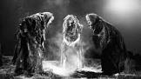
You are going to consider the purpose of the ‘Witches’ in Macbeth today.
Remember, if it wasn’t for the Witches premonition Macbeth may have not carried out his actions that led to his demise.
Shakespeare created tension and apprehension to the audience through the characters of the Witches – audiences feared the supernatural!

Create the Witches speech for a 21st Century audience. You must consider the following:
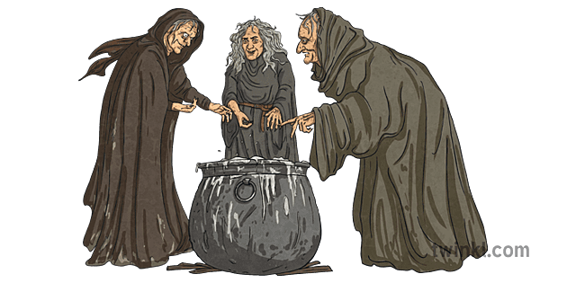
- Perform in-the-round (the audience will be sat in a circle around you)
- Use some or all of the script to create your witches spell – You may use the original language or the modern language script.
- Consider unison/synchronisation – how could you use physical and vocal unison to show the connections between these characters.
- Use a witches cackle or sound to establish who they are
- Creating rhythm through sound-scapes and the words of the text
- Focus on the movement of the witches, hands, feet, body, facial expressions
- How can you fulfil Shakespeare’s original intentions of scaring his audience and putting them on edge!?
- You may use rostra to create a cauldron and/or levels, but do remember your are performing in-the-round and we all need to see!
- You may bring in props/costume to perform.
You will show a work in progress later on in the lesson today.
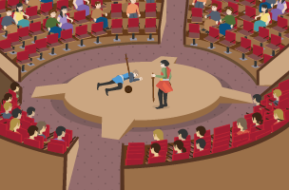
- You must learn your lines for homework

In effect, theatre-in-the-round removes the fourth wall and brings the actor into the same space as the audience. This is often problematic for actors as they must ensure they move about the space so that they can be seen, sometimes backs may be to the audience, something that is unavoidable in this format.

